

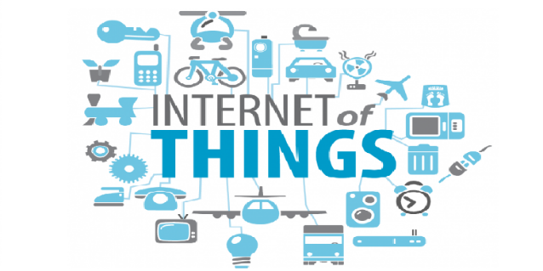



Microsoft Azure Event Hubs and Stream Analytics for IoT Solutions

**By Emmanuel Nuyttens – June 2018**

**Senior .NET Solutions Architect Connected Company - Realdolmen**

# Introduction to Event Hubs & Stream Analytics

***What are Microsoft Azure Event Hubs ?***

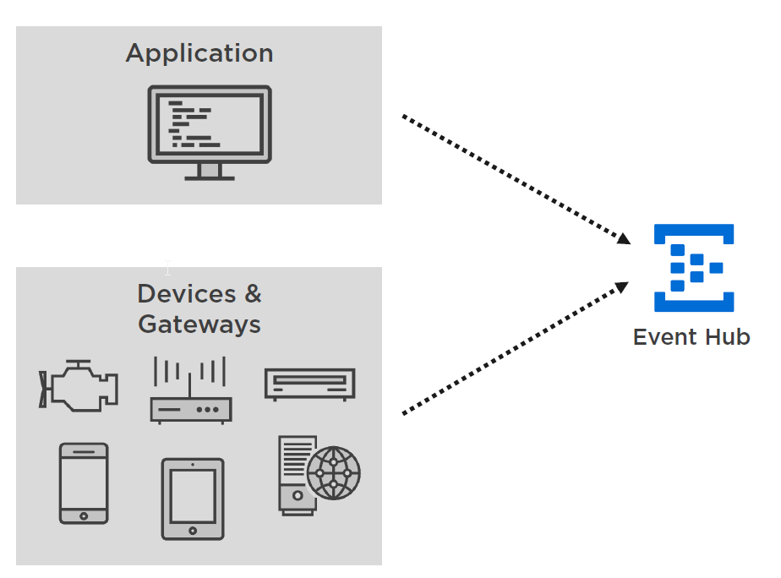

Event hubs are typically “events” ingestors, which means that we can send event-data (e.g. telemetry data) from our applications, or more typically IoT enabled devices like a Raspberry Pi to a central ingestion point, called the **Event Hub.**

**Azure Event Hubs** can be used to collect more than 1 million events per second and the total data volume of these events can be **more then 1 gigabyte per second !**

After applications or devices has sent events to your event hubs, the **Event Hub** can next consume and analyze these events.

By default events are stored in the Event Hub for one day, but this is configurable.

***What are Stream Analytics ?***

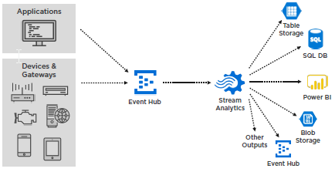

One way to do this is to set up a **Stream Analytics** job in Azure. With Stream Analytics, you can use a SQL-Like query syntax to read and analyze the events from the Event Hub. With Stream Analytics you can group and aggregate data to a certain output format and write the results of your query to an output that you have defined. The output can be for example **Power BI.** In Power BI you can create a real-time dashboard that shows the data coming from the Stream Analytics job, but you are certainly not limited to Power BI, Stream Analytics can also send output results to Table Storage, SQL-DB, Blob-Storage, another Event Hub and other outputs like csv-files, excel, etc.

# Event Hub vs. IoT Hub

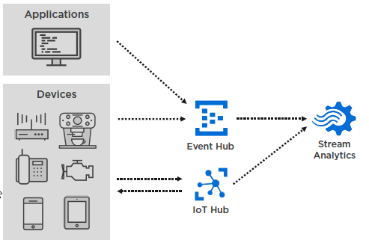

An Azure **IoT Hub** supports a similar concept as an **Event Hub.** You can also send events from your devices to an **IoT Hub** instead, which on their turn can also be consumed by a Stream Analytics job.

The main differences between an Event Hub and an IoT Hub are:

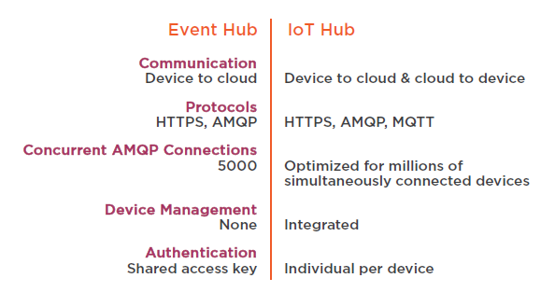

So, to conclude, IoT Hub can be seen as a “specialization” of an Event Hub, in fact an IoT Hub contains an Event Hub “under the hood”, but adds device specific capabilities like device provisioning and cloud to device communication.

# The demo Scenario

## Reading and Sending (Simulated) Sensor Values

I’ve thought out a (fictitious) sample scenario to explain the concepts of Event Hubs and Stream Analytics which I will explain next. As for my next project I will be part of the **FAVV** (Federaal Agentschap voor Voedsel Veiligheid 🡪 Federal Agency for Food Safety) team, I thought out a scenario to remotely check **Freezers.** To keep things simple, the Freezers will be grouped by **City**, so we don’t store an exact address but each Freezer has an unique **FreezerId** and is located in a certain **City** and a City may have many freezers of course.

The FAVV wants to collect data from the different Freezers in different Cities in Belgium to have answers to next questions (which can be seen as the requirements of our scenario):

For each freezer they want to know:

* The current state (on/off).
* The current and max content (in Kg).
* The current temperature (in °C).
* The current Cooling Liquid Level (in %).

Besides the requirements above, the **FAVV CEO** also wants to be notified when the maximum content of a freezer (in Kg) has been exceeded. In this case, he wants to get a message in his **“DropBox”** account which shows the device id, freezer temperature and current and max content of the freezer. Okay, that’s all for now ☺.

We will send the different (simulated)[1] sensor-values (current-state, current & max content, current temperature and cooling liquid level) to an **endpoint** in the **cloud.** This endpoint in the cloud will be an **Event Hub.**

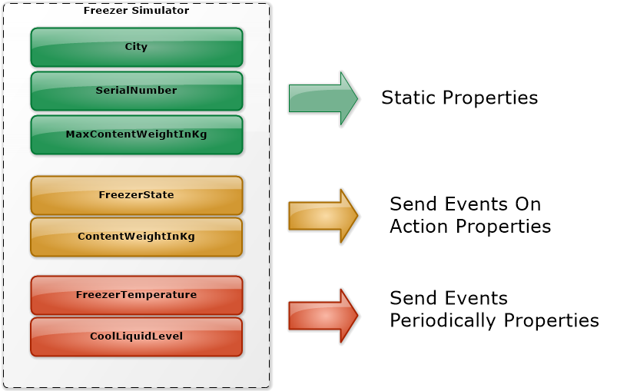

Our Freezer Simulator will have next characteristics:

* ***Static Properties*** (City, SerialNumber & MaxContent) : These are set at creation time and remain static (do not change).
* ***Send Events on Action Properties*** (FreezerState, Content): Altering these properties will trigger a send_events message to the Event Hub.
* ***Send Events Periodically Properties*** (FreezerTemperature, CoolLiquidLevel) : Propagating changes to this kind of properties will typically be done by a background task which periodically send the state to the Event Hub.

## Analyzing, Processing and Reporting the Telemetry Data

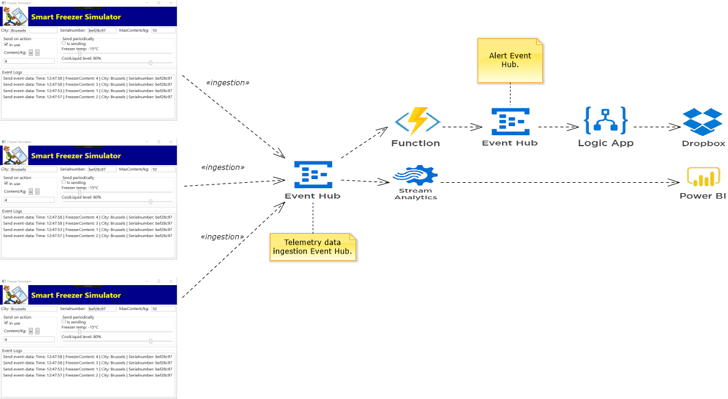

* Send on Action Sensor Data (freezer state on/off & freezer content change) are send to the **Telemetry data ingestion Event Hub** only when the state of the properties changes.
* Current Freezer Temperature and current Cooling Liquid Level are send at a timed interval (e.g. every 5 seconds) to the **Telemetry data ingestion Event Hub**.
* An **Azure Function** is used to filter event telemetry data for events where the current content of the freezer exceeds the maximum content of the freezer and result is send to the **Alert** **Event Hub.** Finally, an **Azure Logic App** is configured to receive events of the **Alert Event Hub** and put a formatted message in a **DropBox** instance of the CEO’s DropBox account.
* An **Azure Stream Analytics instance** is used to receive events from the **Telemetry data ingestion** **Event Hub** and capture changes to the **Current Freezer Temperature** and **Cool Liquid Level.** The result of the Stream Analytics is provided to a **Power BI** dashboard where the changes are reported in real-time, in our case this means that the freezer temperature graph and cool liquid level graph are adapted accordingly, as shown below:

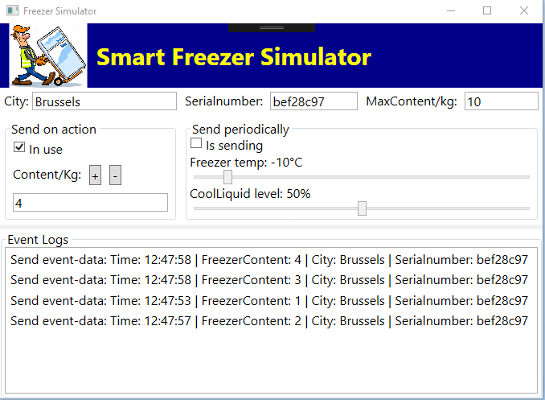

In our Freeze Simulator, when the user changes the slider values, then the events will be picked up by the **ingestion Event Hub** and processed by the **Stream Analytics job** which will filter the events for the temperature and cool liquid level changes and provide them as **real-time** values to the **power-bi** dashboard.

# Building a Freezer Simulator in WPF

## The User Interface



In a real production environment we would use a sensor-enabled device (like a Raspberry PI or a Freezer brand specific device) to capture the data from a real freezer. But as the focus of the document is on capturing and sending telemetry event-data to an Azure Event Hub, simulating the real sensor data through a Freezer simulating device is far good enough.

Even more we could use an interface and dependency injection framework to make the code device independent (so we could easily switch between a real and a simulating device), but for this demo, let’s keep things simple and not implement any dependency injection framework.

The only thing that we will do is to host the sending part and events-data class (Freezer Data) in a separate .NET Standard library, so the sending code is not “tight-coupled” to the simulator app. The only thing that differs from a real device is that the events-data will be generated from the values in the UI, in contrast to a real device, where the events-data will be generated from the device-specific sensor-data. So if we separate the logic and data from the UI, then were fine to go …

Though I kept the interface fairly simple, our use case is complex enough to demonstrate the most important parts of using Event Hubs and Streaming Analytics. As already mentioned in the introduction part of this document, we have static data (City,SerialNumber,MaxContent) which will be provided in each event-data send-event. Next we have freezer state and current content which will generate a telemetry data send-event each time when the underlying data changes and finally we have the freezer temperature and cool liquid levels which will be send on a periodical base and be controlled by a background tasks.

## Implement the MainViewModel

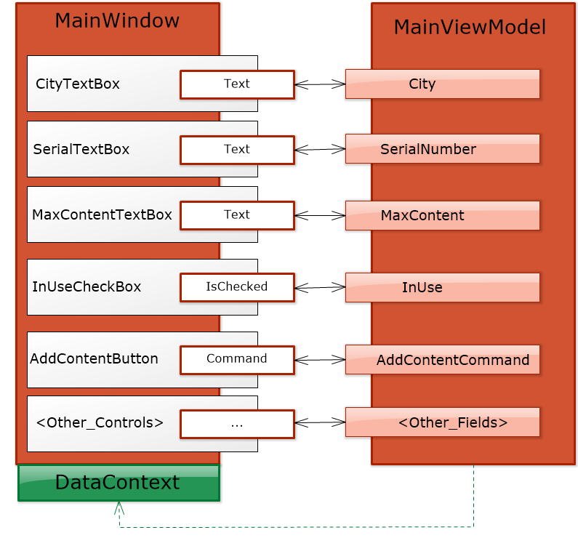

It is a common approach and best practice to separate the user interface elements from the user interface logic. This makes our application simpler to implement and to test. In this demo, I use the MVVM (Model-View-ViewModel) pattern which is common practice in windows based application development like WPF, UWP and Xamarin.

It is not the intend of this document to go to into the details of MVVM but the main concept is that each View (MainWindow in our case) has a corresponding ViewModel (MainViewModel in our case) and each “bindable” property in the View has it’s corresponding twin in the VM. The DataContext of the View is bound to an instance of a ViewModel (VM) and each change in View is propagated to the VM and vice versa. Finally the VM also contains the necessary Commands (e.g. Add ContentCommand) logic which will create the appropriate data-event message to be send to our sending service layer implemented in a separate .NET Standard library.

## Setting Up an Event Hub in Azure

### Introduction

In this chapter we will create and configure an **EventHub** in Azure, more specific we will create the **Telemetry data ingestion Event Hub** to send our freezer telemetry data event messages to. The steps are:

* Setup an Event Hub in Azure portal:
  + An Event Hub is part of an Event Hub namespace.
* Configure Throughput Units and Partitions.
  + Throughput units and Partitions are used to scale your Event Hub, so it can for example process more events per second.
* How to calculate the costs of your Event Hub.

### Event Hub Setup in Azure Portal

Goto: <https://portal.azure.com>

We will first create a new **Resource Group** in the Azure Portal. As the word says, resource groups are used to group things together. For our SmartFreezer scenario we create a resource group called **smartfreezer-rs.**

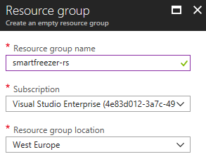

Next create a new Event Hub:

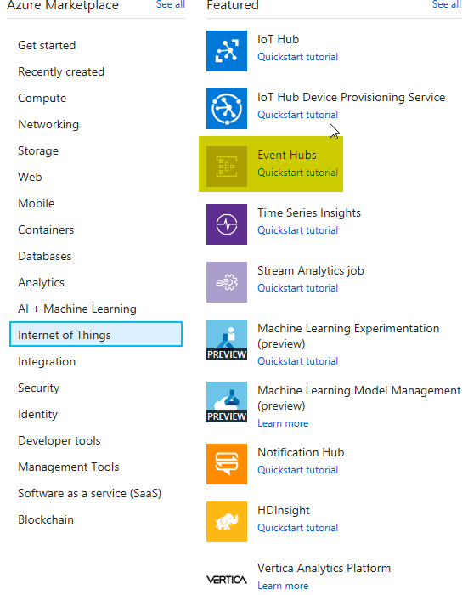

First we have to create an Event Hub namespace:

|  |  |
| --- | --- |
|  | By default, let the number of throughput units to 1 and do not enable auto-inflate. Click create to create the Event Hub namespace. |

Next we create the Event Hub within the Event Hub Namespace:

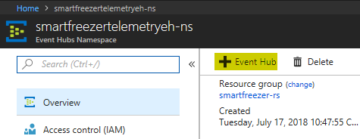

Leave all defaults and click “Create” to create the Event Hub.

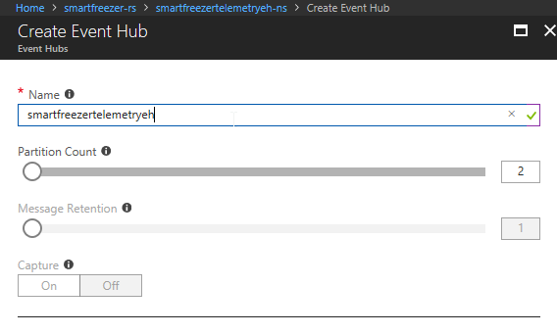

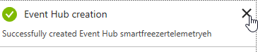

Now we have an Event Hub namespace with a Telemetry Event Hub:

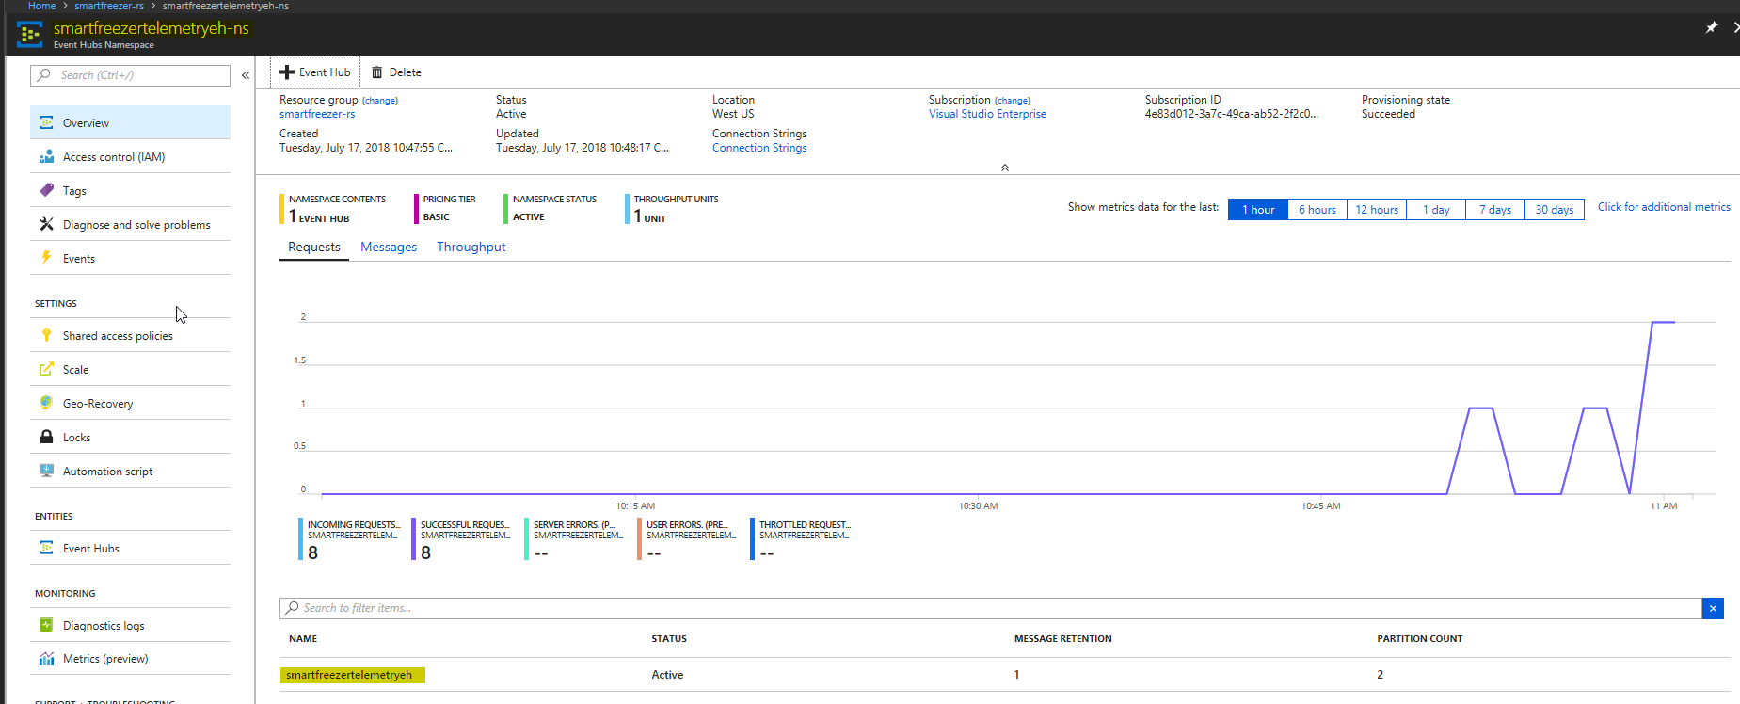

### Understand Throughput Units

**Throughput Units** are defined on the **Event Hub namespace** level.

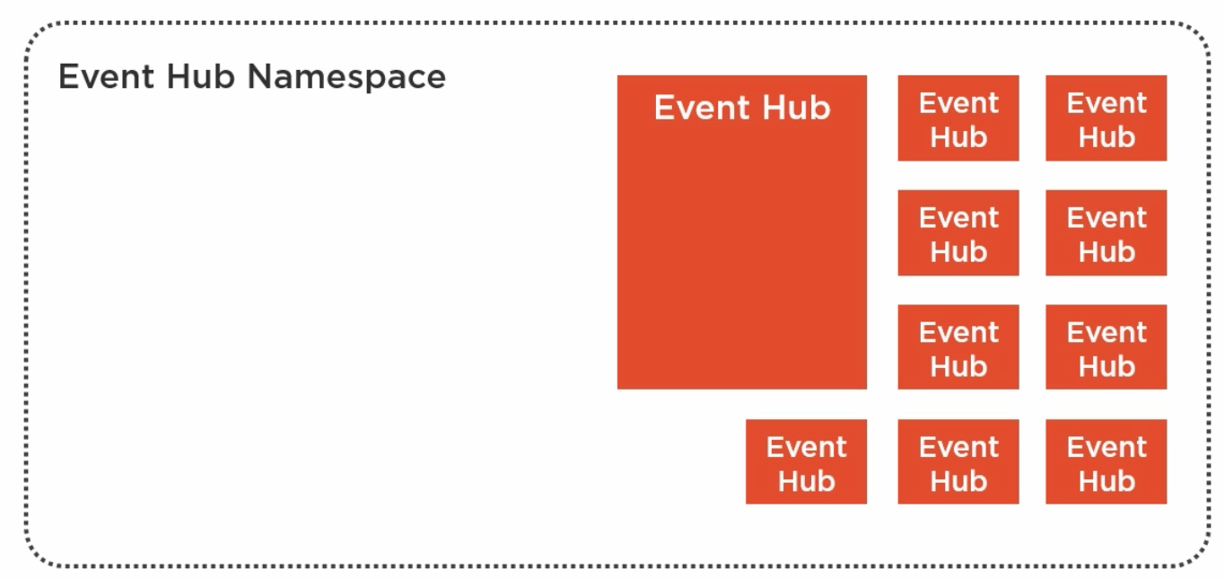

We started to create an **Event Hub namespace** and created an **Event Hub** in the Event Hub namespace. An Event Hub namespace can contain up to 10 Event Hubs. On the namespace level, we have selected just 1 **Throughput Unit** by default and which is the minimum number of Throughput Units you can choose.

The maximum number of Throughput Units that you can select in the Azure portal is **20.** The Throughput Unit is a reserved capacity.

The single Throughput Unit gives your Event Hub namespace the capacity to handle 1 MB/s (megabyte per second) or 1000 events/s, whichever of the 2 comes first of incoming data, the so-called **ingress** data. It gives your Event Hub namespace also the capacity to handle 2 MB/s or 2000 events/s of outgoing data, also called **egress** data.

Throughput Units are defined at the namespace level. This means that the Event Hubs in that namespace share these Throughput Units. If you have like in the image above 10 Event Hubs in you namespace and you have defined just a single Throughput Unit, then you have a capacity that supports on average 100 KB or 100 events/s of ingress data per Event Hub.

Of course, if 9 Event Hubs are inactive, the single active one can take all the capacity that the single Throughput Unit provides !

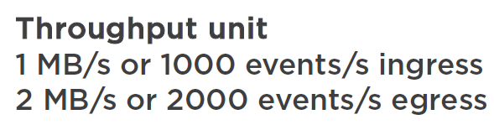

|  |  |
| --- | --- |
|  | **Warning:**  *There is an important point regarding throughput units, that is you have to pay for them. On a standard Event Hub a Throughput Unit costs 0.02 EUR / hour which is about 18.80 EUR / month. That’s why you want to keep the number of Throughput Units as low as possible !* |

### Throttling and Auto Inflate

But what happens actually if the Event Hub in your Event Hub namespace receives more events than the defined number of throughput units could handle ?

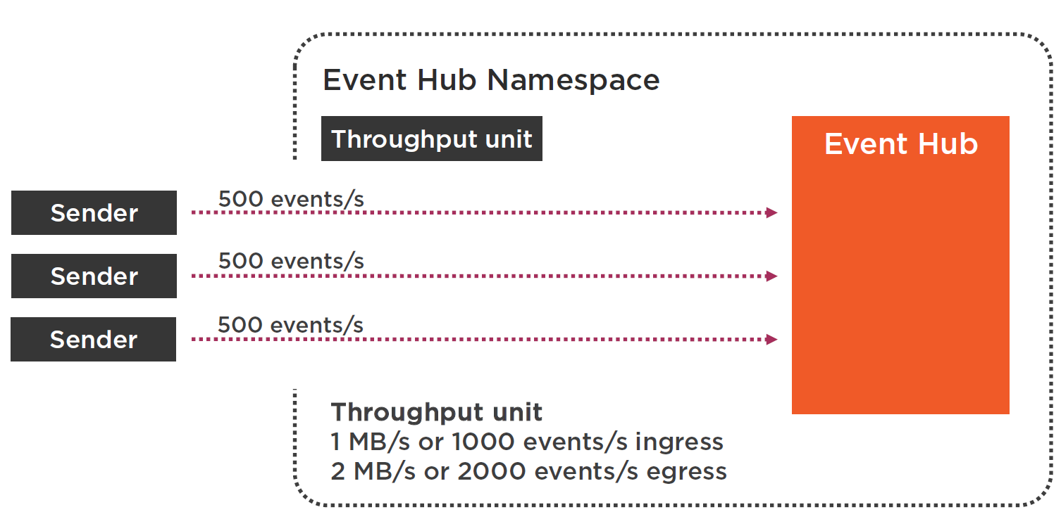

Imagine that we just defined a single throughput unit on our Event Hub namespace. A single throughput unit can take 1 MB/s or 1000 events/s as ingress, but what happens when, for example, senders are sending 1500 events/s to your Event Hub ? This is more then a single throughput unit can handle with its capacity of 1000 events/s !

If you don’t add more throughput units to your Event Hub namespace, senders will be **throttled.** They will receive **errors** when they send events to your Event Hub. The errors will tell the sender that the **ingress quota** is exceeded. Consumers of your Event Hub won’t be affected by this throttling as long as the egress quota is not exceeded !

To avoid throttling for your senders, you need to increase the number of **throughput units** to 2. Two throughput units are (in our example) enough to handle the 1500 incoming events per second, they could even handle 2000 incoming events per second !

To increase the number of throughput units you have 2 options:

* Increase throughput units automatically by using the **auto-inflate** option.
* Increase throughput units manually.

To change this, we have to go to our Event Hub namespace scale setting:

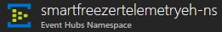

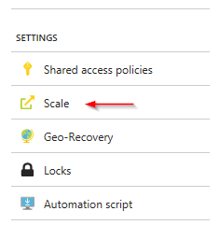



Here you can see the default number of throughput units set to 1, next if you switch to “Standard” you can set the “Auto-Inflate” option.

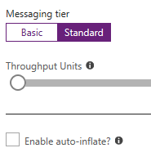

If you check the “Enable auto-inflate”, you can set the maximum number of throughput units that can be activated in the Event Hub namespace=20.



You can set for example that the max number of throughput units can not auto-inflate more then 4 units. You can also disable auto-inflate and you can just set the number of throughput units manually:

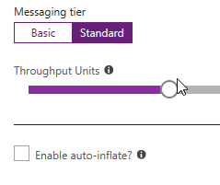

|  |  |
| --- | --- |
|  | **Warning:**  *The issue with* ***manual-scaling*** *is that you have to notice that your senders or receivers are* ***throttled****. With the* ***auto-inflate*** *option, senders and receivers are never throttled until the upper limit is reached !* |
|  | **Warning:**  *Auto-Inflate only increases the number of throughput units when needed, it doesn’t decrease them automatically when not needed anymore !* |
|  | **Info:**  *Although the maximum number of throughput units / event hub namespace is limited to 20, this means 20 MB/s or 20.000 events per second for ingress data and even twice as much for egress, which is a massive amount. When you need more then 20 TPU then you can raise a support request ! It will allow you to handle more then 1 million events per second !* |

### Understand Partitions

By default, when you create a new event hub you get 2 Event Hub **partitions**, which is the default value and also minimum number of partitions you can select.

But what is such a partition ? When senders are sending events to you Event Hub, these sent events are distributed to partitions by using a **round robin model.**

The partition itself is a data organization mechanism to store an **ordered sequence of events.** New arriving events are added to the end of that sequence. The partitions of an Event Hub are independent from each other. That’s the reason why they usually grow to different sizes. Every partition has its own sequence of data.

|  |  |
| --- | --- |
|  | **Info:**  When you plan the number of partitions for your Event Hub, keep in mind that you pay for the number of TPU but not for the number of partitions. Partitions don’t add any costs to your Event Hub. |

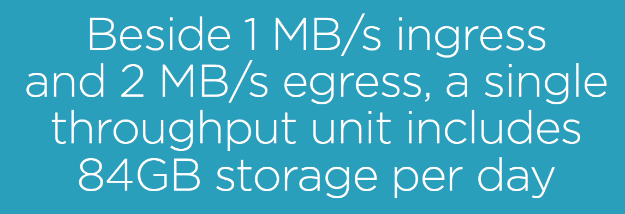

How to decide on the number of partitions ?

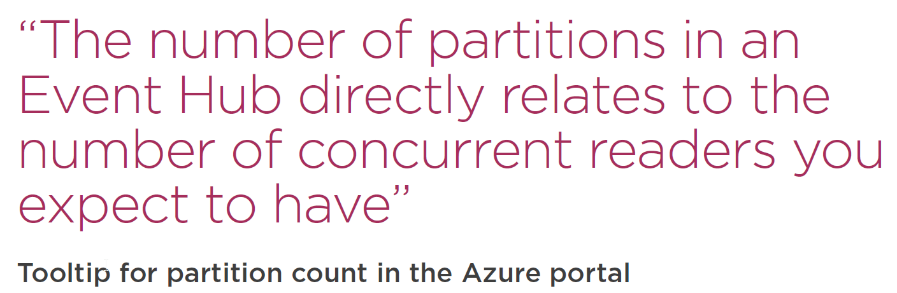

That means, for example, if you expect a maximum of 2 concurrent Consumers, then 2 partitions are the right choice. You can only set the number of partitions once when you create the Event Hub.

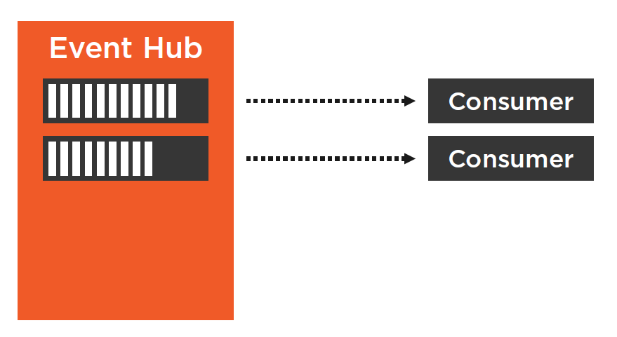

### Calculate the Event Hub Costs



## Implement the Sending part as a separate .NET Standard Library

### Architectural Overview

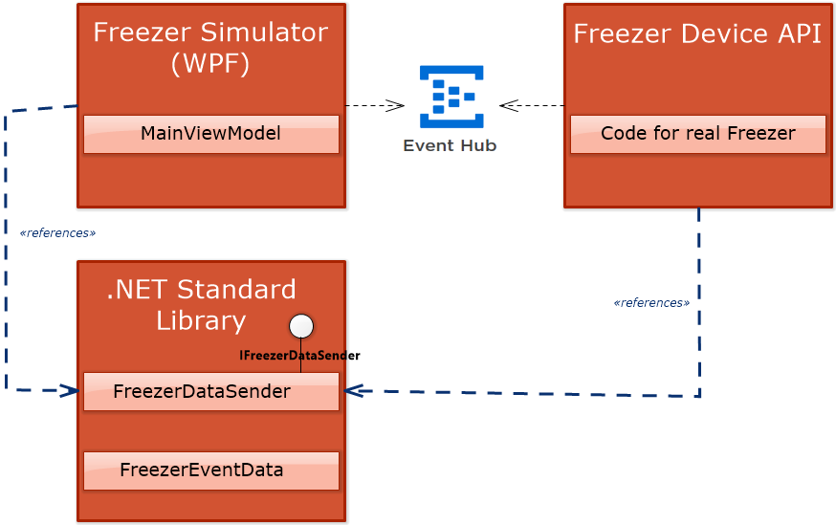

The **FreezerDataSender** is responsible for sending the freezer events to the **Telemerty data ingestion Event Hub.** As we will not only use the FreezerDataSender class in our Freezer Simulator application, the sending part is hosted in it’s own library (.NET Standard Library, so it can be referenced by different .NET project types). To make it possible to swap out the sender class by alternative implementations, the class has an interface implementation.

### Send Events to the Event Hub

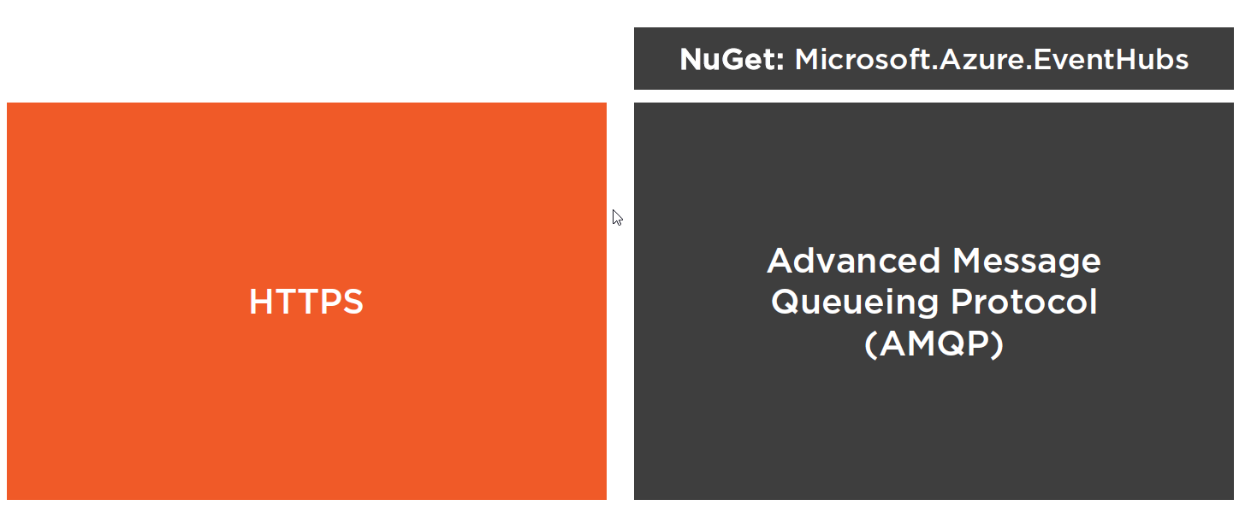

To send events to the Event Hub you can either use **HTTPS** or **AMQP.** AMQP is an open standard protocol for messaging and it is more efficient then HTTPS. For this demo we will use AMQP. In .NET you can use the **Microsoft.Azure.EventHubs** nuget package that will use **AMQP** under the hood.

The code for sending event data is quit obvious, first we have to accept a connectionstring in our datasender constructor method (which can be stored in an app.config file) and create an **EventHubClient** instance from the **Microsoft.Azure.EventHubs** nuget package.

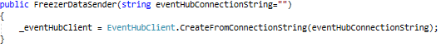

Next we need a method that converts the incoming **freezerEventdata** object into an **EventData** object which can be consumed from the **EventHub Send** method.

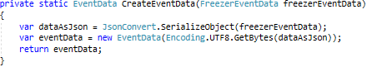

Finally we send the event object to the **EventHub.**

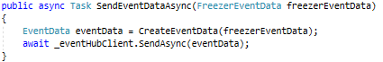

### Batch Multiple Events

There is also the possibility to send events in **batch.** This can be useful for our **periodical sent** events (freezer temperature and freezer cooling liquid levels). Instead of creating a separate event for temperature and cooling liquid, we can batch them into a single event and send a single event to the **event hub** instead.

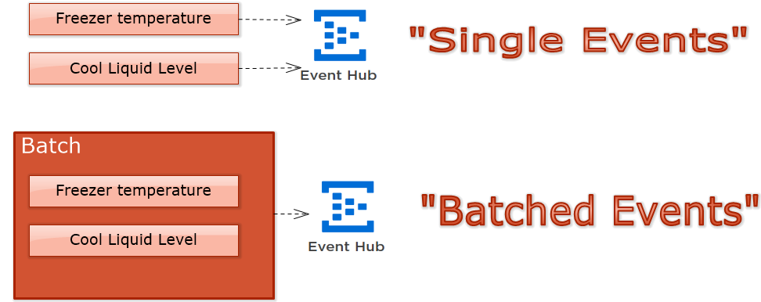

|  |  |
| --- | --- |
|  | **Info:**  *Batching multiple events into a single message is heavily reducing the number of packet headers that are sent over the network ! This means that batching will reduce network bandwidth.* |

To batch events, the **EventHubClient** has an overload of the **SendAsync** method that takes an **IEnumerable** of **EventData** objects, as shown next:

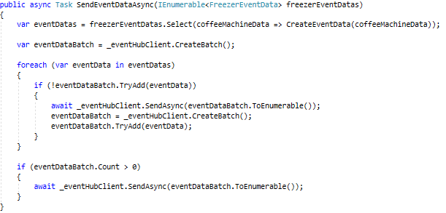

When you send events to your Event Hubs it’s important to keep the message size limit. The standard Event Hub has a default message size limit of **256 KB max.**

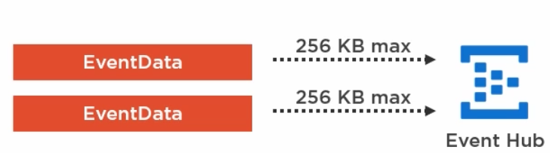

|  |  |
| --- | --- |
|  | **Warning:**  *If you send more than 256KB/message, then you will get a message size exceeded exception, that’s why it is important to use the* ***CreateBatch()*** *method on the Event Hub Client**and using the* ***TryAdd()*** *method to limit the batch to the maximum message size, as shown in the code above. The code above will create multiple “batches” if message size exceeds 256 Kb !* |

### Set up a Shared Access Policy and Send Events

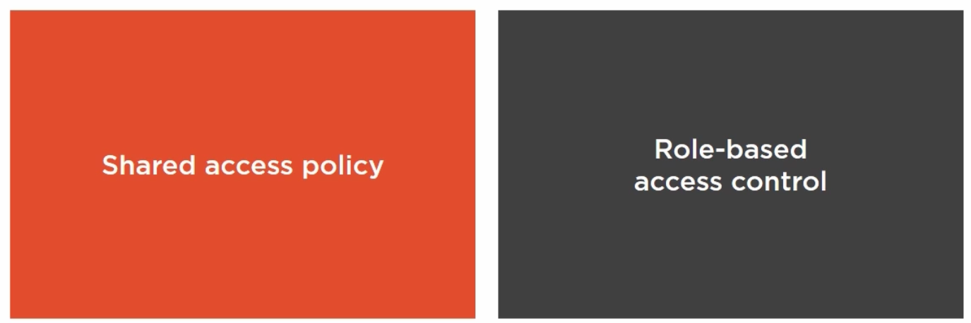

To send events to the Event Hub, you need a connection string. You get such a connection string by setting up a **shared access policy** in the Azure portal. Beside an authentication with a connection string and with a shared access policy, an Event Hub supports also **role-based access control.** With role based access control you can use **active directory** to control the access to you Event Hub. For our demo, we use **shared access policies.**

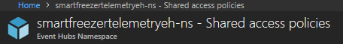

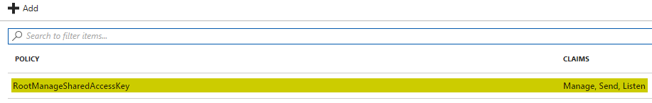

By default there is already a default policy called **RootManagedSharedAccessKey** with claims Manage,Send,Listen.

|  |  |
| --- | --- |
|  | **Info:**  *We won’t use the* ***RootManagedSharedAccessKey*** *because it gives you full access to manage the namespace and to send and listen to* ***all Event Hub’s*** *in that namespace !* |

Instead of giving full access with this **RootManagedSharedAccessKey** you should give access only to the **Event Hub** to which you want to send events or from which you want to listen.

So we first have to select our Event Hub:

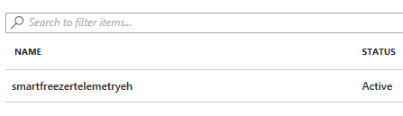

Next select **Shared access policies** for the specific **EventHub,** in our case **smartfreezertelemetryeh** and click “Add”. We will create a policy to “Send” and “Listen”:

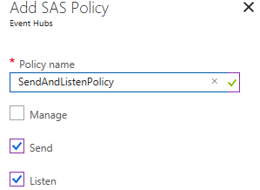

Next we can copy the created connection string to our clipboard:

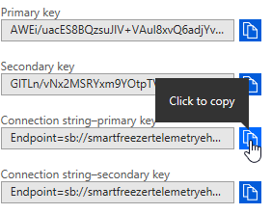

### Adapt the Connection String in App.Config

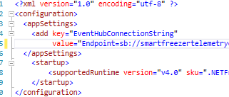

# Consuming Events

## Introduction

In this part we will look how we can **read events** from an **Event Hub**. We will use a **.NET Core Console App** to illustrate this.

There are 2 major ways to receive events from an Event Hub:

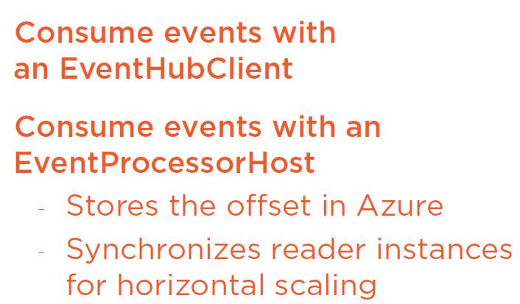

**EventProcessorHost** is an abstraction that is using an **EventHubClient** as a base. It adds additional features on top. E.g. it stores the offset in Azure. So if you stop your application and start it again, it will read alle the events it hasn’t read yet by using the offset. It supports also horizontal scaling so you can start multiple instances of your application to scale.

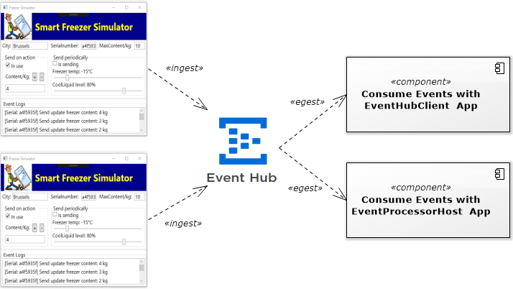

## Consume Events with Event Hub Client

We will create a Console Application (.NET Core for this purpose) and will initialize an **EventHubClient** instance in that application. Next we will use the **EventHubClient** instance to create a **PartitionReceiver** which will be used to receive events from our **Telemetry data Event Hub** (SmartFreezer data events).

A **PartitionReceiver** receives events from a specific **Partition** of our Event Hub. As mentioned before, the number of partitions in an Event Hub is set when the hub is created and is defaulted to **2 partitions**, as shown below for our **Telemetry data Event Hub:**

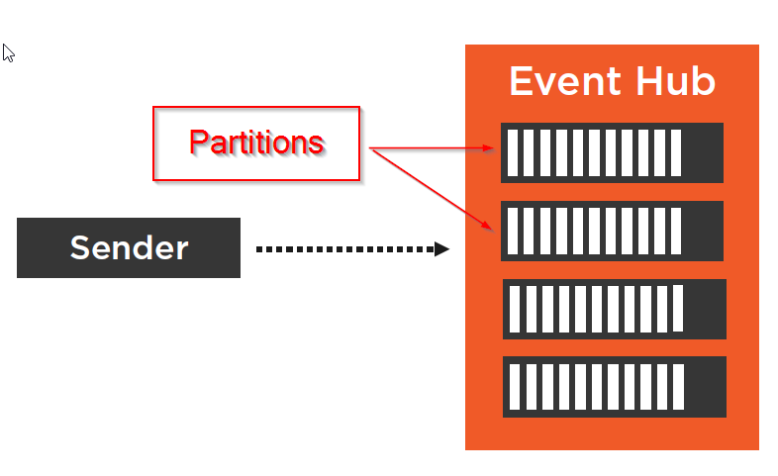

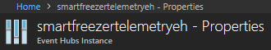

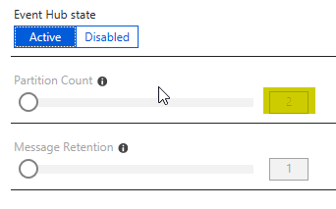

Besides receiving events from a **single partition,** we can also receive events from all partitions by using the EventHub Client. In this case we have to create **multiple partition receivers** as many as we have **partitions** in our **Event Hub !**

Finally we will also learn how to **deserialize** a **FreezerEventData** object from the received **JSON** string.

### Consume Events from a Single Partition

We create a .NET Core console app and add next **nuget-package** first:

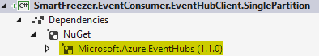

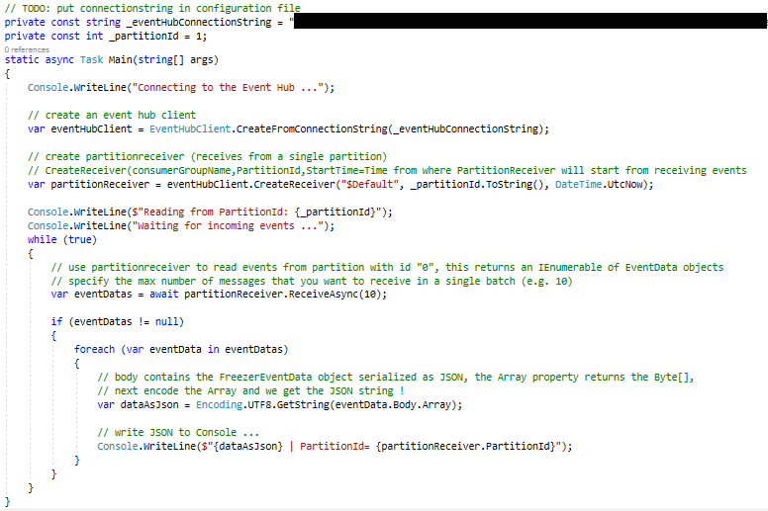

The image above contains the code to read from a single partition of our Event Hub. It starts to create a new Event Hub, we specify the $Default consuming group, partition 0 and start time to read events is current UTC.Now. Next we create an infinite loop and read 10 next messages in a batch. Finally we extract the JSON from the message body and write it to the console.

Let’s start both the consumer and client and generate some event data …

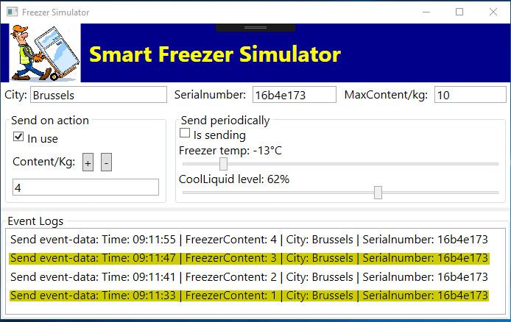

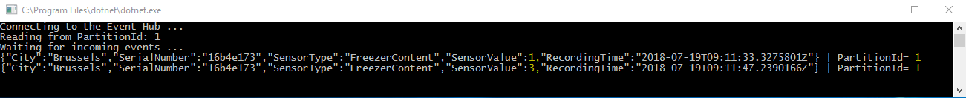

What’s interesting is that although we send 4 events, we only consume 2 of them. The reason is that we only consume from Partition with id “1” and the other Events are in partition “0” ! So let’s adapt this behavior and read from “all partitions” of our Event Hub instead.

### Consume Events from All Partitions

When you want to receive **all events** from your Event Hub, you need to receive the events from **all partitions** of your Event Hub. That means that you need to create **a PartitionReceiver for every partition**.

We can find out the number of Partitions the Event Hub has assigned by using the EventHubClient instance. That is what we will do next …

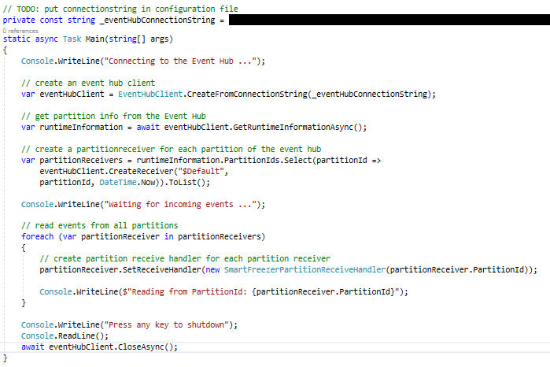

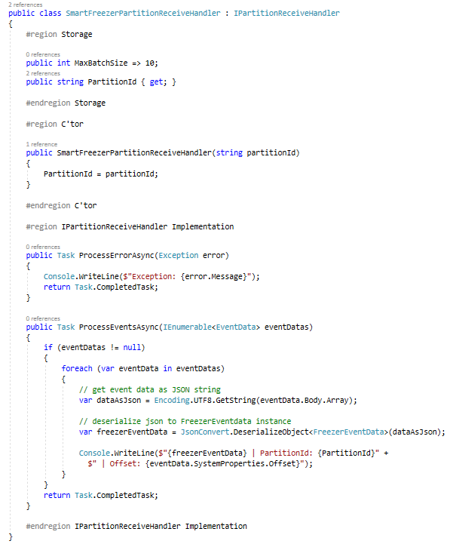

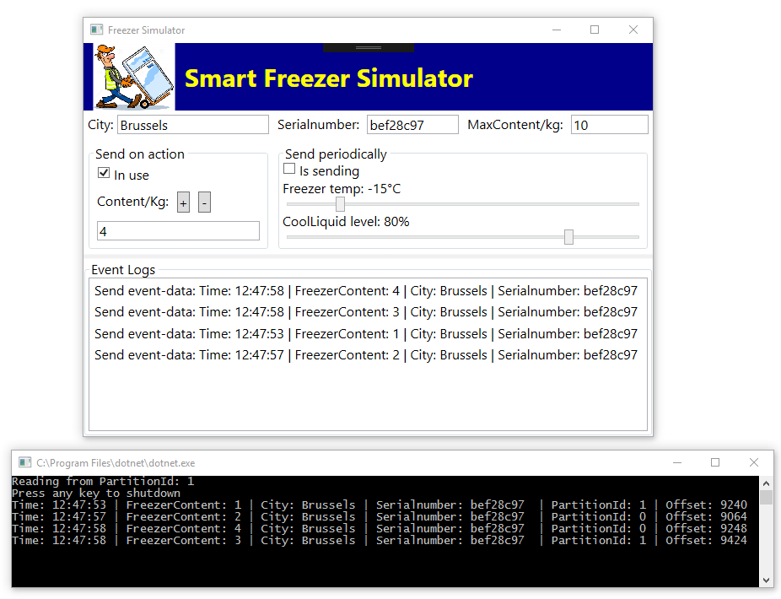

In this case, we create **a partitionreceiver for each partition of our Event Hub** and use the **ProcessEventsAsync** class implementation to process the incoming events. I’ve also parsed the JSON string to the appropriate EventDataClass so we can use the ToString() method to display the data, which makes the output equal to what is presented in the UI-Log.

### Reading Events from a Specific Offset

When senders are sending events to **Event Hubs** these events are distributed to partition by using a Round Robin model, which means that the incoming events are distritbuted evenly to the partitions of the Event Hub.

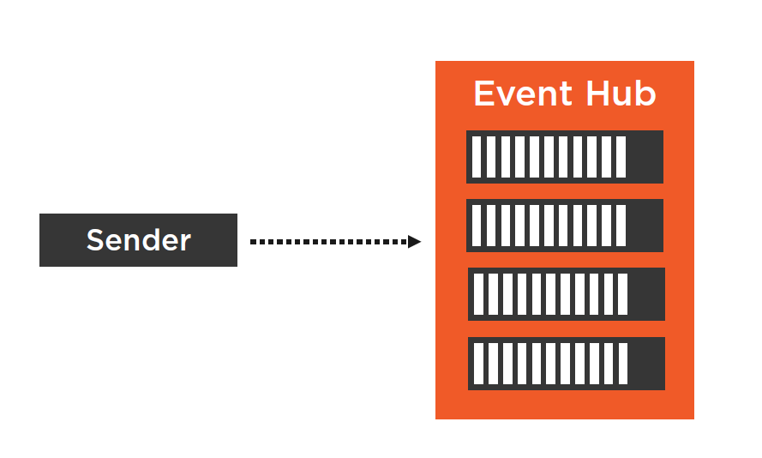

Within a single partition, incoming events are ordered (FIFO = First-In-First-Out), but that is not true if multiple partitions are used (e.g. message 1 can be taken by partition 1 and message 2 by partition 2 bu message 2 can be processed earlier).

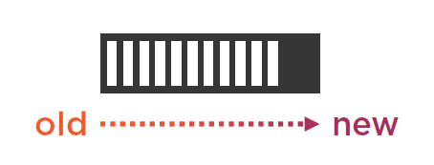(=single partition = ordered message handling).

As we saw before, you also need a Partition Receiver to receiver events from an Event Hub Partition and it is also a good idea to use a separate Consumer Group for each event consumer (this will be explained in next chapter).

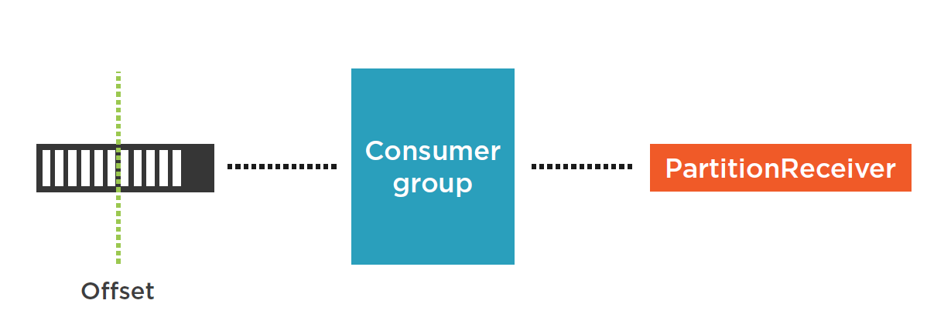

The ordered events in a single partition has an “Offset” and you can use the Offset to read from a specific position within the Partition. This way you can read all events which are newer then the specified “Offset”. The example below shows how we can addthe “Offset” to our output:

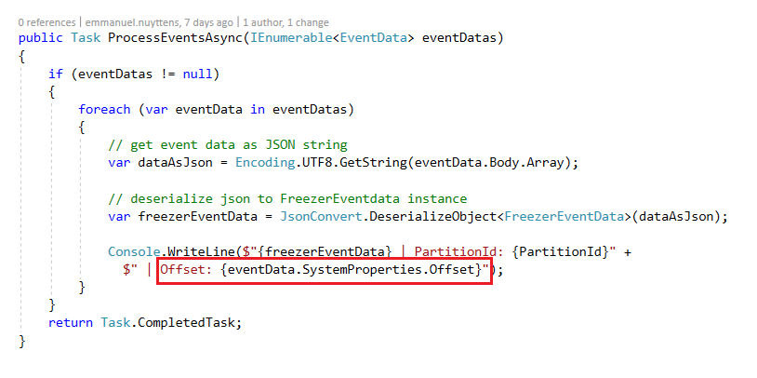

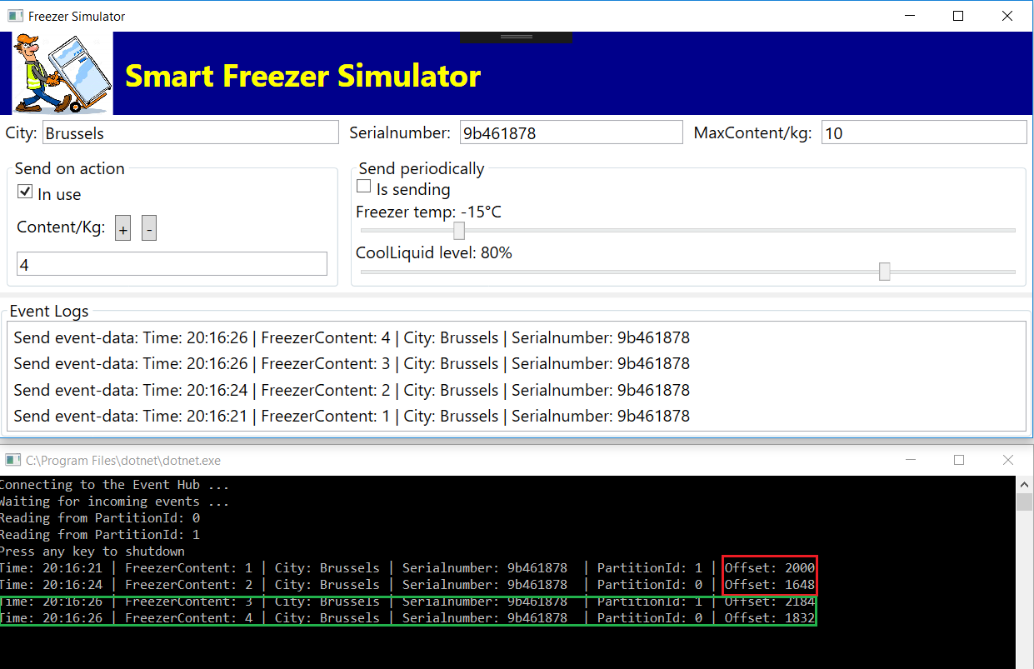

We have send 4 events to the Event Hub, by using the round robin 2 events are sent to partition 1 and 2 events are sent to partition 2. If we want for example to only output the last 2 events (with Offset 2184 and 1832), then we take the 2 Offsets of each partition before these Offsets (2000 for partition 1 and 1648 for partition 0) and we adapt our event output console as next:

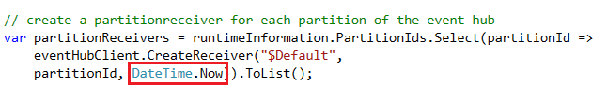

When we created the partition receivers, we passed the **DateTime.Now** as parameters. By doing this all events were listed. If we want to skip some events then we have to put the Offset from the first and second partition where we want to start skipping from:

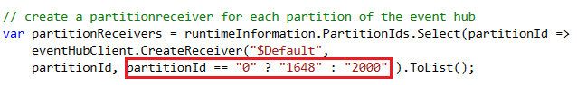

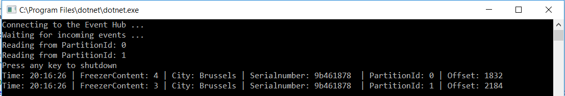

There is also an overload “OffsetInclusive” which takes a Boolean and when set, all events will be shown starting from and Offset inclusive, so in our case we will get our 4 events:

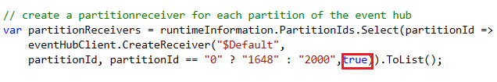

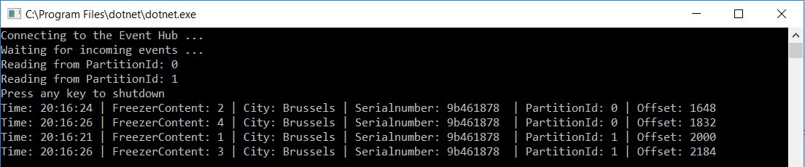

|  |  |
| --- | --- |
|  | **Info:**  *Now you could store the offsets in a database, so when the application which reads the get’s down then you can replay them. But you don’t have to do that manually, because there is an alternative called* ***Event Processor Host*** *which has built-in support for* ***Offset*** *persistence. We will look at the Event Processor Host next.* |

### Understand ConsumerGroups

When we use the Event Hub Client to consume events we had to create Partition Receivers (as many as partitions in our Event Hub). Next each Partition Receiver will read events from a specific partition of the Event Hub. In our demo case we have an Event Hub with 2 partitions defined, so we need 2 Partition Receivers. Partition Receivers need a Consumer Group (default: $Default) to read the events from the Event Hub.

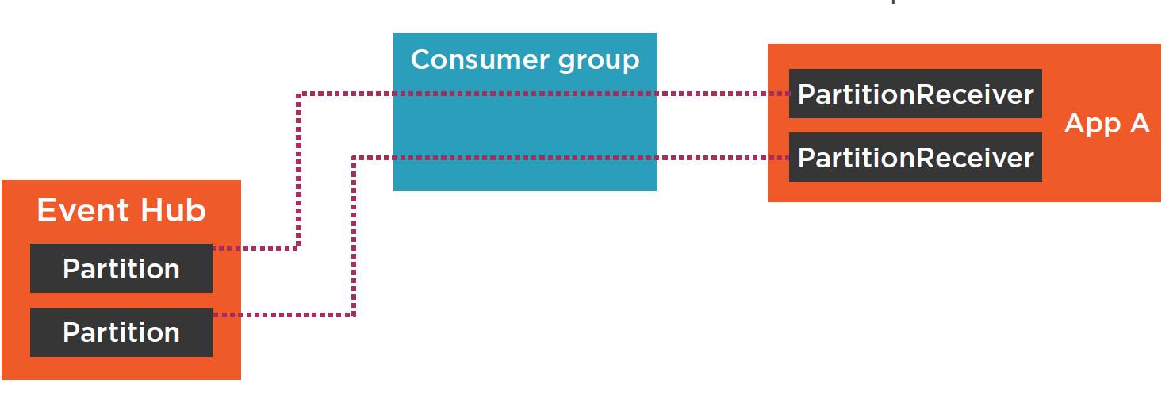

Now assume that we have next to App A another App (let’s call it App B) which want to read events from the Partitions of the Event Hub. App B will also need Partition Receivers and a Consumer Group to read the events from the Event Hub. Question is if App B should use the same Consumer group as App A ?

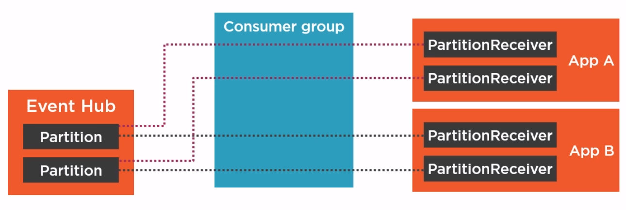

The answer is no ! Because :

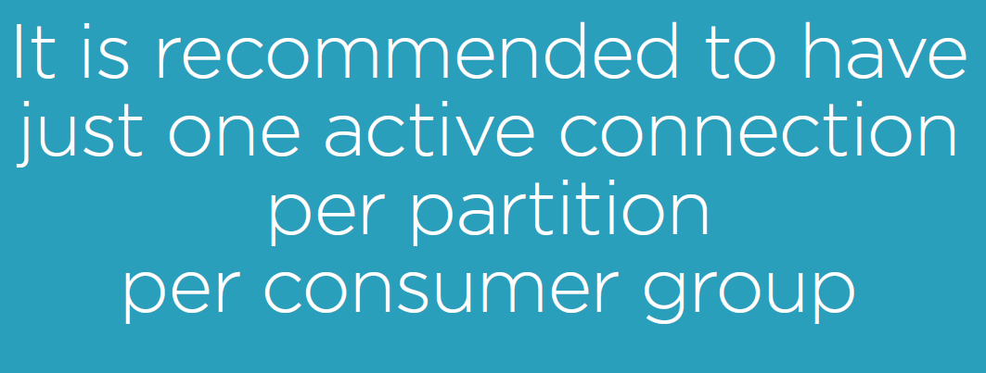

So we should create a separate consumer group for App A and App B as shown below:

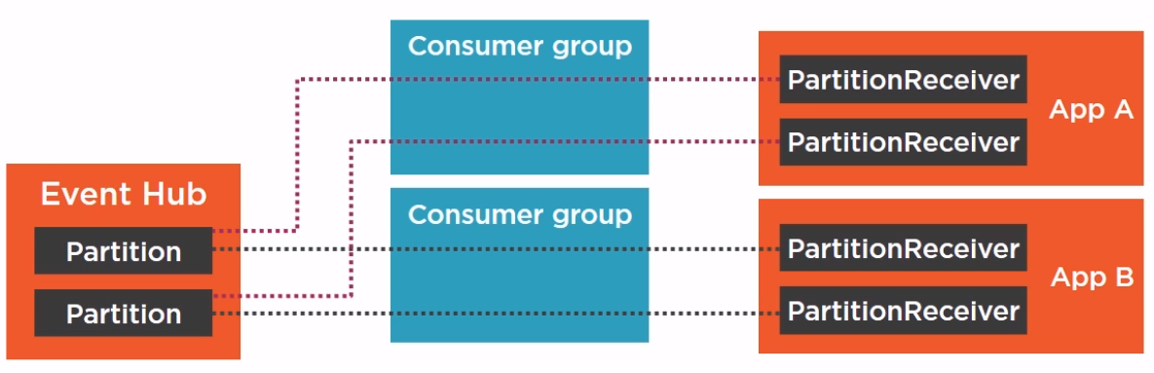

A Consumer Group is like a SELECT * VIEW on the Event Hub.

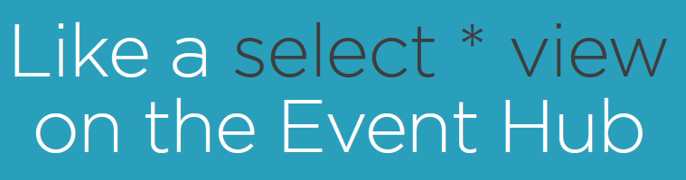

Each consumer group provides the full event stream to the consuming application. This means that App A and App B can read independently from each other in parallel from the Event Hub.

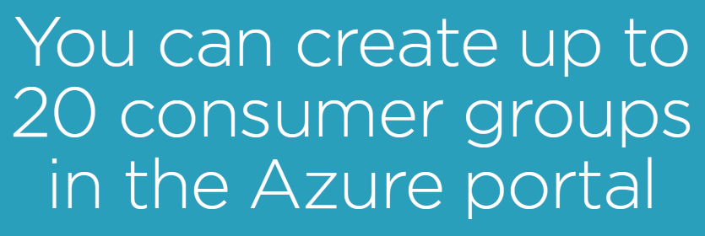

This means that you can have up to 20 applications that can read completely in parallel from your Event Hub. You should create a Consumer Group for every application that you build.

|  |  |
| --- | --- |
|  | Consumer Groups has to be set on the level of the Event Hub, section ENTITIES, Consumer groups. You can only enter a name for a Consumer group, we create one for our EventProcessHost application that we will create shortly: |

### Understand Partitions

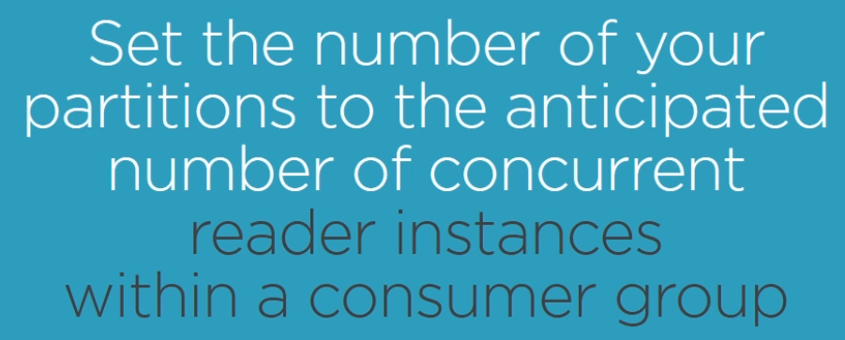

Let’s say that we have created an Event Hub with 2 partitions and we have created a .NET application with 2 Partition Receivers, you have a consumer group, and the application is reading the events from the Event Hub’s partitions, as shown below:

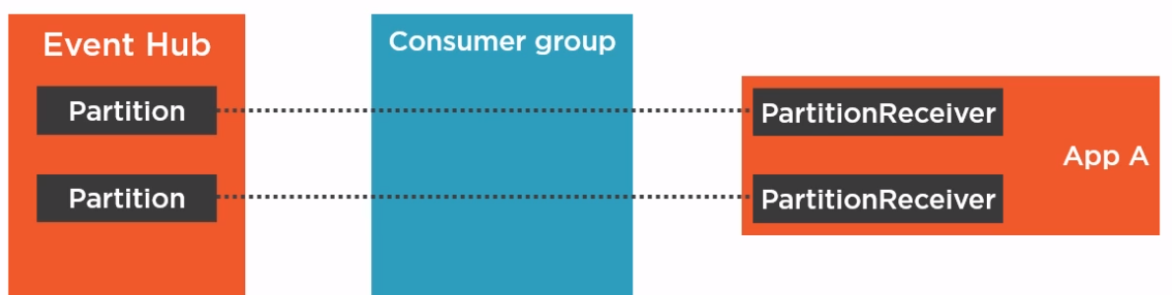

Now let’s assume that your application (App A) is not able to handle the incoming events from the Event Hub. To be able to handle the amount of incoming events in your application you need to split up the work to 2 processes (instances of your App A).

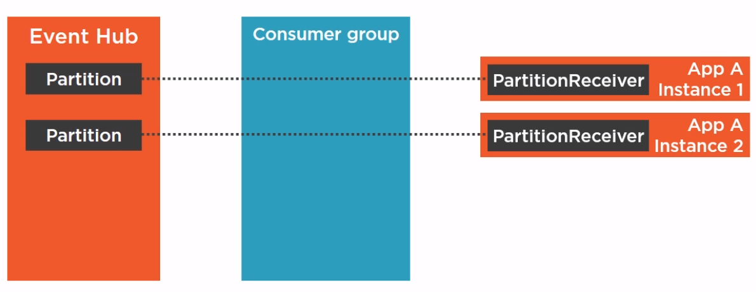

So the Partition Receivers will be automatically assigned to the App’s (in our case 1 partition per App Ainstance to read the events from. Now let’s assume that after some load testing scenario’s we need 4 instances of App A to get the work done.

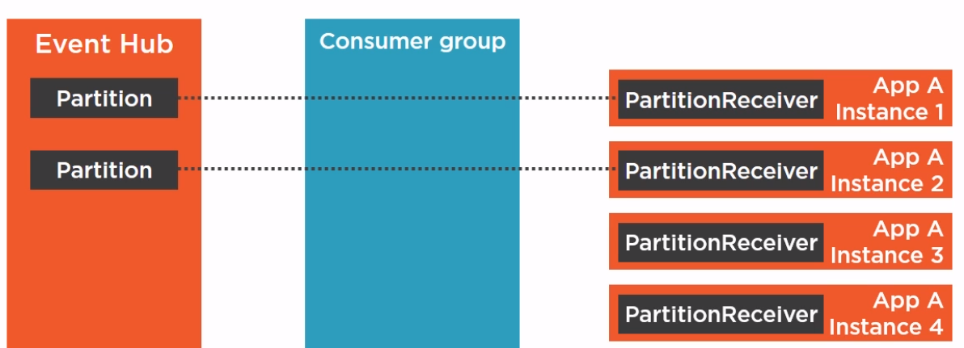

You will also have a Partition Receiver on Instance 3 and 4 but unfortunately we have no more Paritions to read from in our Event Hub, as it defines only 2 Partitions ! So if you want to have 4 concurrent reader instances then you have to create 4 partitions in your Event Hub !

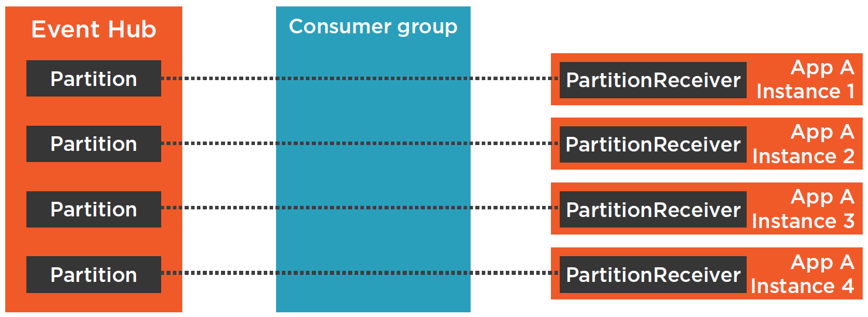

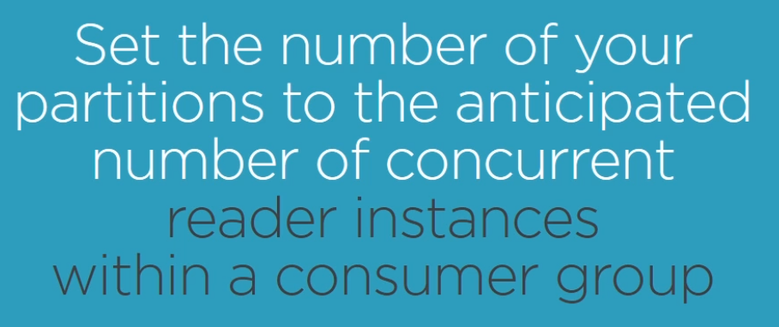

Now imagine that at some point in time, a single instance of the App can handle all incoming events, then you have only 1 instance running which will take advantage of 4 partitions, as mentioned below:

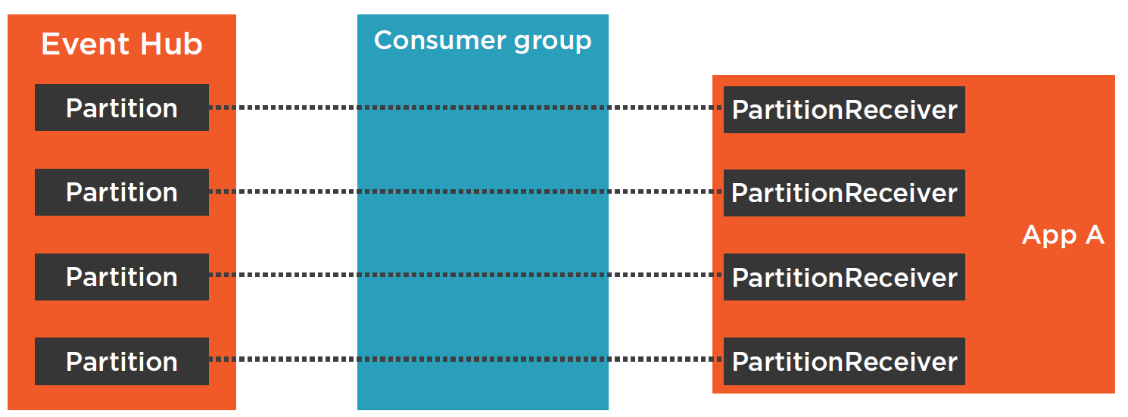

## Consume Events with an EventProcessorHost

### EventProcessorHost Overview

In the former chapter we learned how to receive Events from the Event Hub by using the EventHubClient, which gives you direct access to the partitions of your Event Hub and it’s available via the NuGet package “Microsoft.Azure.EventHubs”. Now we will see how we can use the EventProcessorHost class to receive events from an Event Hub.

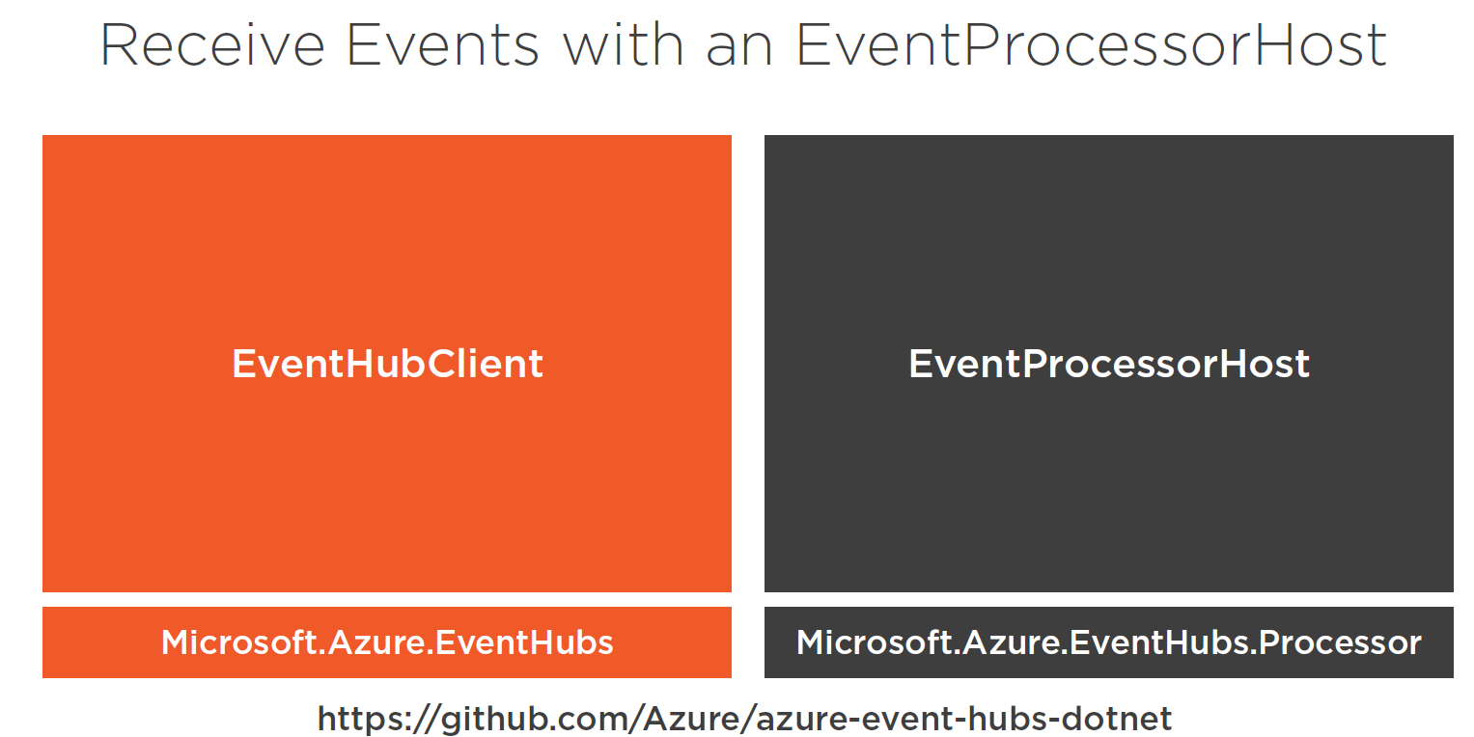

The EventProcessorHost class is available via the NuGet package “Microsoft.Azure.EventHubs.Processor” , the code is available on GitHub:

<https://github.com/azure/azure-event-hubs-dotnet>

EventHubClient is the most direct way to access events which are stored in an Event Hub as it gives direct access to the Event Hub’s partitions. EventProcessorHost is a high-level abstraction that is using an EventHubClient under the hood.

The EventProcessHost add’s extra features like automatic offset handling and reader synchronization.

To illustrate this, let’s assume that you have created an Event Hub with 4 partitions, and you have a .NET application and you want to read all the events from that Event Hub by using a EventProcessorHost. You do this by implementing the IEventProcessor interface in your consuming application. After you implemented this Interface you register your implementation with an EventProcessorHost.

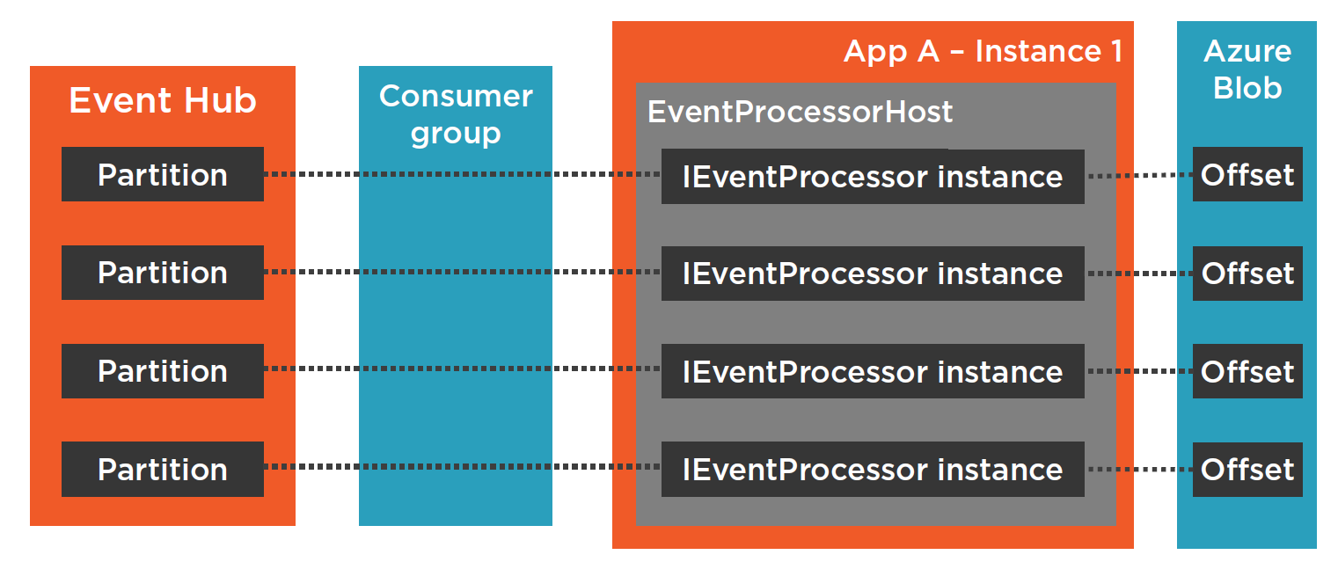

Now when you run an instance of your application, the EventProcessorHost will create an instance of your IEventProcessor implementation. But not only 1 instance, it will create an instance for every partition and these EventProcessors will connect to the partitions of your Event Hub. Under the hood, an EventHubClient and PartitionReceivers are used. But as EventProcessorHost is an “Abstraction” you don’t see the EventHubClient and you don’t see the PartitionReceivers.

To access the Event Hub with an EventProcessorHost you also need a consumer group as every consuming application has to be part of a consumer group ! Now we come to the interesting part with the EventProcessorHost. Every IProcessor instance is storing the partition Offset in an Azure Blob Storage. This means that when you stop your consuming application and you restart it later then the EventProcessor will read the Offsets from the Azure Blob Storage and they will automatically continue from where they stopped before.

Beside this Offset handling, another feature of the EventProcessorHost is reader synchronization for scaling. Let’s assume a single instance of your application is not enough to handle the incoming events from the Event Hub. Then you just start up a second instance of your application, and the EventProcessorHost will automatically balance out these 2 application instances. This means that application instance 1 will automatically connect to only 2 partitions, and application instance 2 will take over the other 2 partitions ! Now the load is balanced across 2 application instances, and the EventProcessorHost does all this for you automatically !

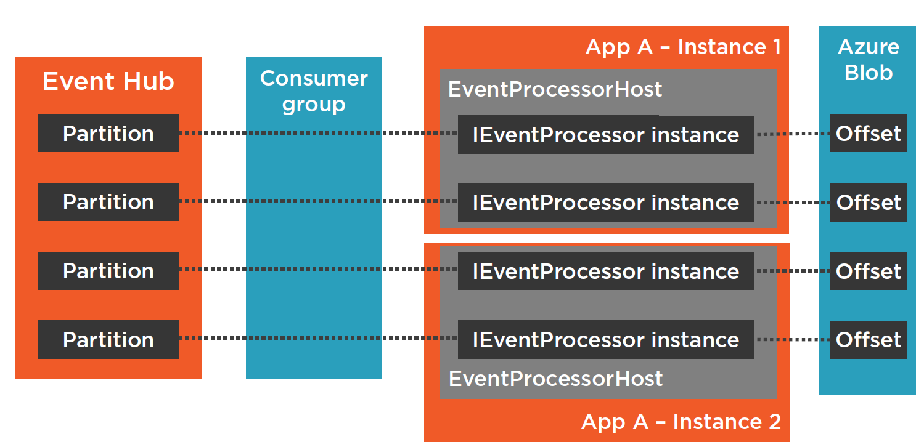

### Build .NET Core Console App with EventProcessorHost

#### Create an EventProcessorHost

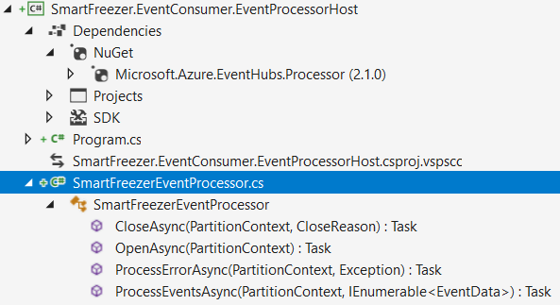

We create a .NET Core console app to host our SmartFreezer EventProcessorHost consumer. We have to add a reference to the Microsoft.Azure.EventHubs.Processor NuGet package first. Next we create an SmartFreezerEventProcessor class which implements the IEventProcessor interface. Besides the OpenAsync, CloseAsync and ProcessErrorAsync method implementations, the most important part is the implementation of the ProcessEventAsync method, which we will detail next:

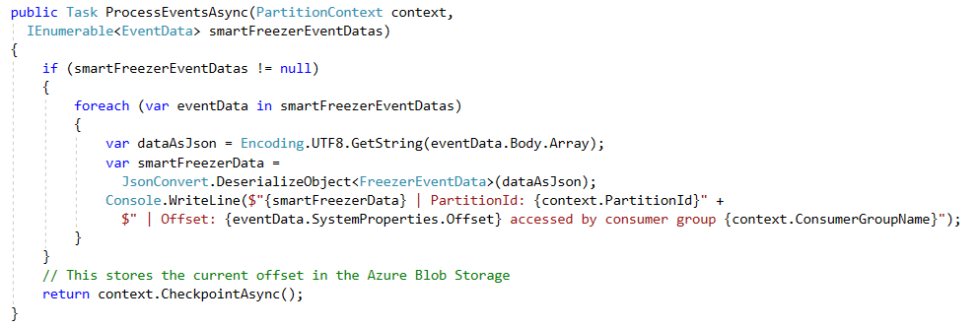

The ProcessEventsAsync method implementation takes a partition context and collection of event data as input. It next iterates over all event data (which comes from the different partitions) and deserializes the to a <FreezerEventData> object and outputs the content to the console.

#### Register IEventProcessor with EventProcessorhost

Next we discuss how to register the SmartFreezerEventProcessor with an EventProcessorHost. We will also provide the several required parameters to create the EventProcessorHost. These parameters are the EventHubConnectionString, the Consumer group name , a storage connection string and also an azure blob storage container name.

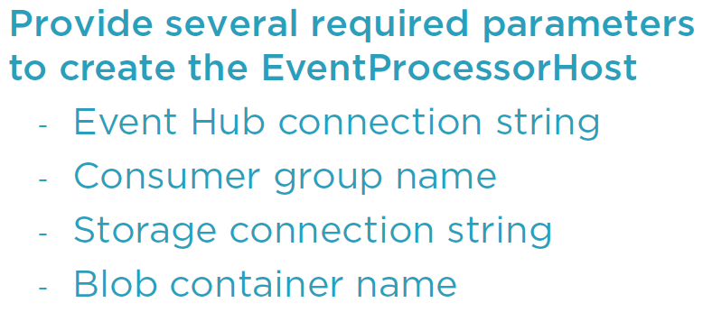

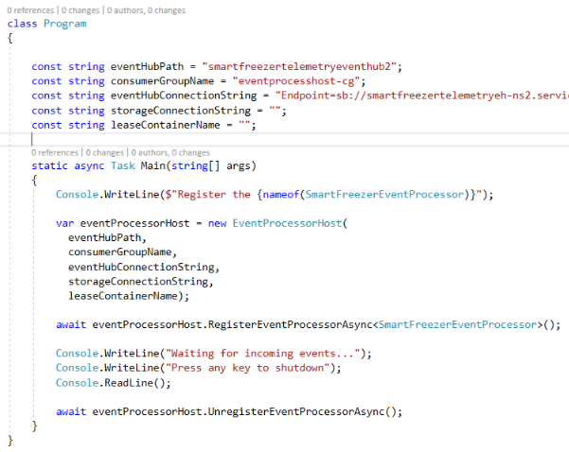



You may wander why we have to set the **eventhubname** in both **eventhubPath** and **eventHubConnectionString** variables ? This is because you can setup a **shared access policy** on the event hub namespace and on the event hub itself. Because we have used the policy as defined on the event hub, we must set the eventhubpath. In case that we should have used the shared access policy on the namespace then the “EntityPath=” would not be part of the eventHubConnectionString and should be set on eventHubPath variable.

We register the <SmartFreezerEventProcessor> in the Program.cs class and start the events consuming process. When the user “hits” any key, the reading process is stopped and the EventProcessorHost shuts down.

We have now 1 missing piece, and that is the storage account to store the events in blob storage to store the Offset for later usage.

#### Setup and Use a Storage Account in Azure

We will create a Storage Account that we can use for our EventProcessorHost.

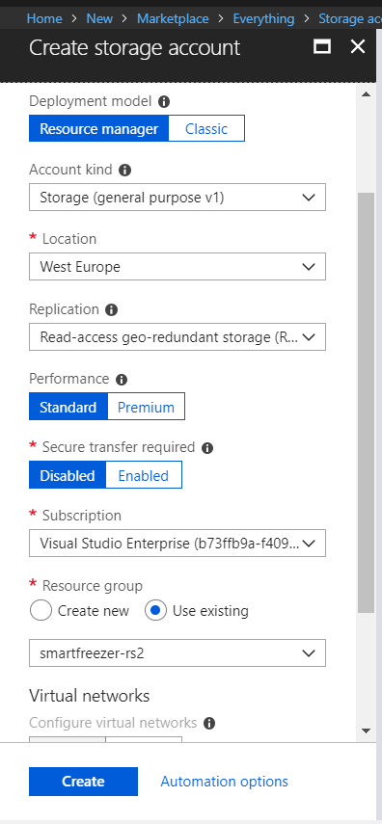

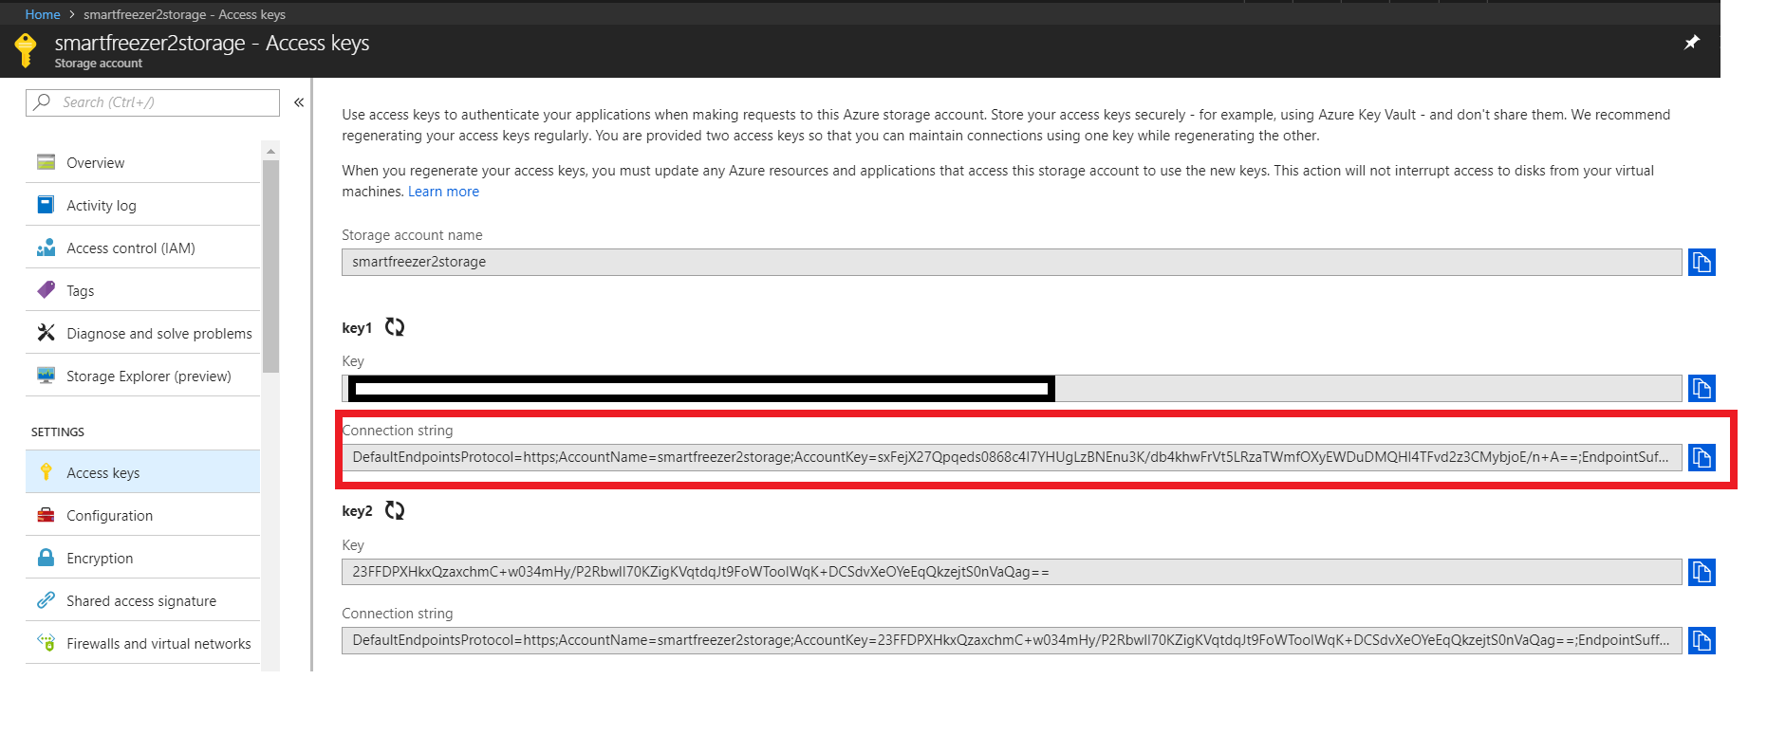

Next copy the connectionstring for the storage account and add it to the program.cs file constant declaration, as next:

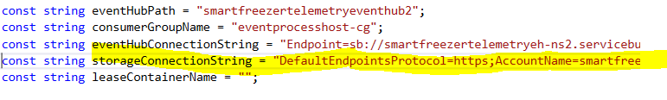

Finally, we have to set the “leaseContainerName” constant. This refers to the name of the blob-container that is used by the event processors to store their OffSets. You can enter a name of your choice, let’s call it smartfreezerprocesscheckpoint.

const string leaseContainerName = "smartfreezerprocesscheckpoint";

The application is now ready to run ! We can now a freezer simulator and the EventProcessorHost consumer app in parallel and send some data:

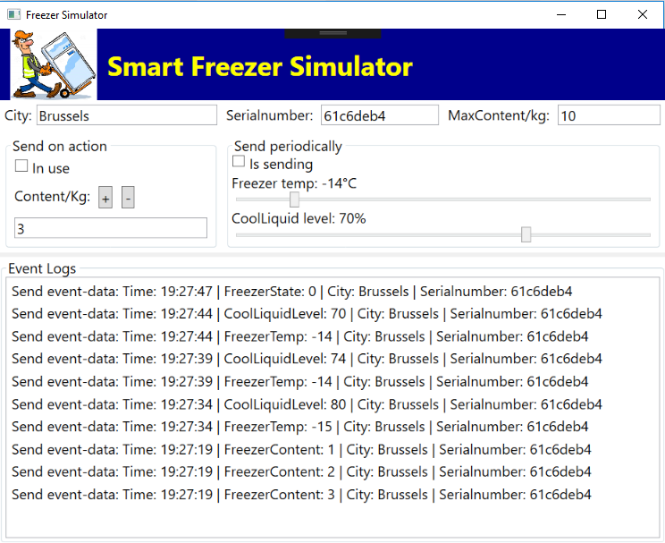

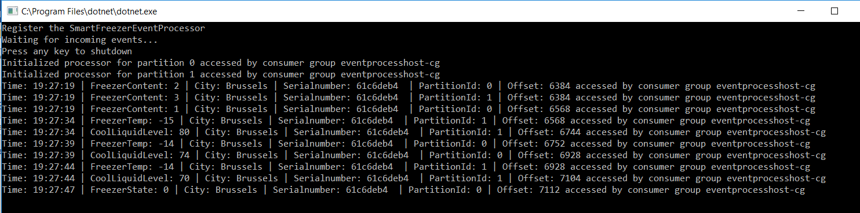

#### Offset Handling with EventProcessorHost

We will look at the OffSet handling and look what is stored in the blob container that is used by the EventProcessorHost. Finally we will have a look at the reader synchronization that is a feature of the EventProcessorHost.

##### OffSet Handling

To demonstrate the OffSet handling we will start a Freezer Simulator in parallel with a consuming EventProcessorHost instance and send some data. Next we will stop the EventProcessorHost but still send Freezer Simulator data. When we restart the EvenProcessorHost consuming app it should restart from the last event output to the console.

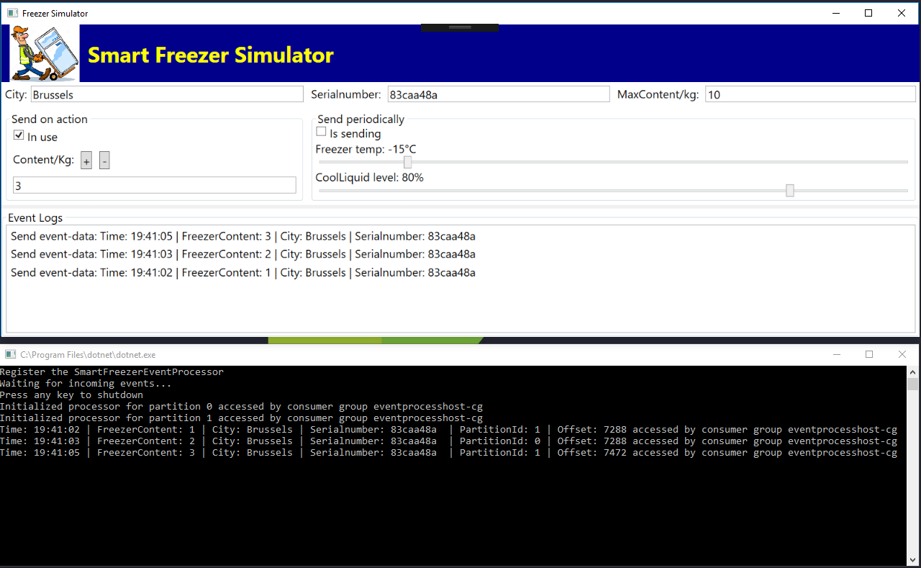

Next we stop the EventProcessorHost consuming app but we continue to send events from the freezer simulator app:

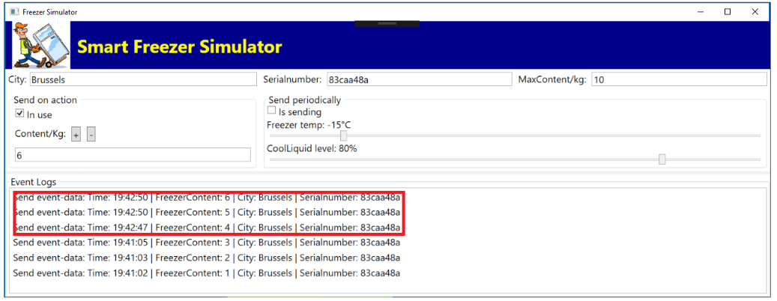

And we restart the EventProcessorHost app:

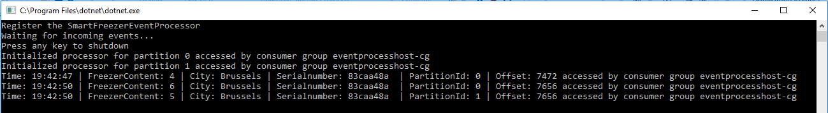

It prints out the events which weren’t processed yet !

##### Azure Blob Storage Persistence used by the EventProcessorHost

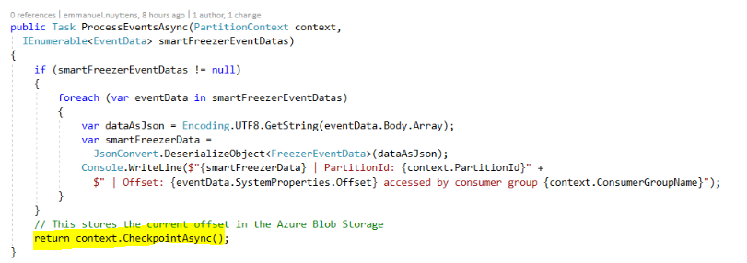

Let’s have a look at the blob storage. Todo this, goto “View” and open the “Cloud Explorer”.

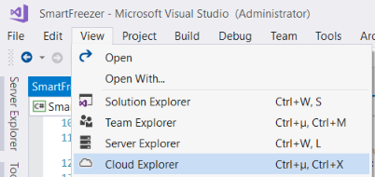

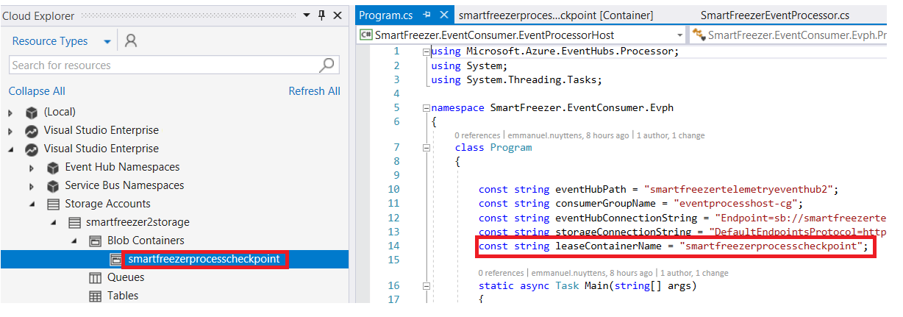

Smartfreezerprocesscheckpoint is set as the name of the container, so the EventProcessorHost app has created a Blob Container with this name. When we click on the container we see a folder with the name of the consumer group:



When you click on the folder you see next:

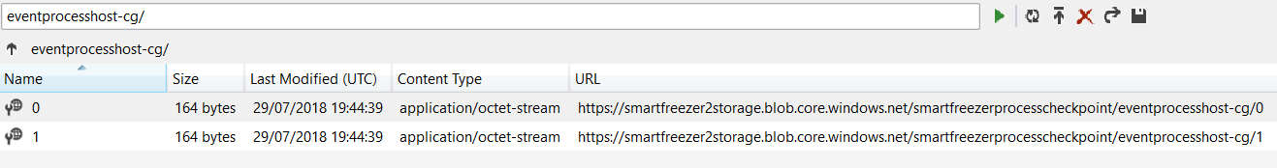

These represent the partitions of our Event Hub. When we open one of the files we get next:

{

"Offset":"7656",

"SequenceNumber":42,

"PartitionId":"0",

"Owner":"host-e3916ff2-2d7a-443f-96bc-e1e0f8dfeec4",

"Token":"6d187676-2563-4cb2-8b18-d13cd7424107",

"Epoch":5

}

Here you see fields like Offset and PartitionId. The OffSet number contains the OffSet for the event which has lastly been processed for Partition with id 0.

#### Reader Synchronization

Reader Synchronization means that it will automatically load balance multiple reading instances.

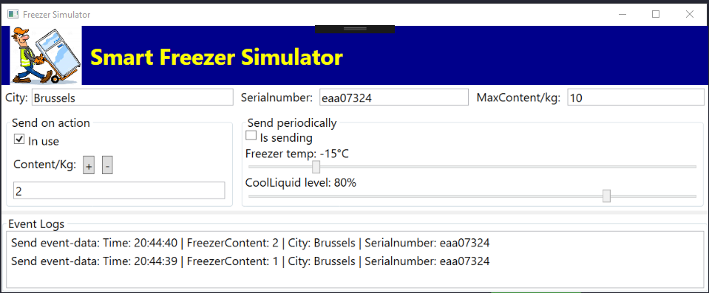

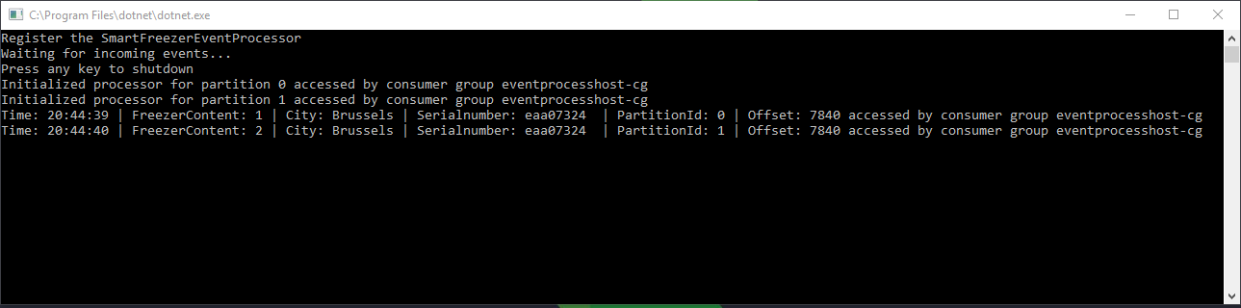

If we start a first reader instance, all events will be processed by this instance. Next if we start a second instance, the first will loose a “lease” to 1 of the partitions, which is now taken by the second instance:

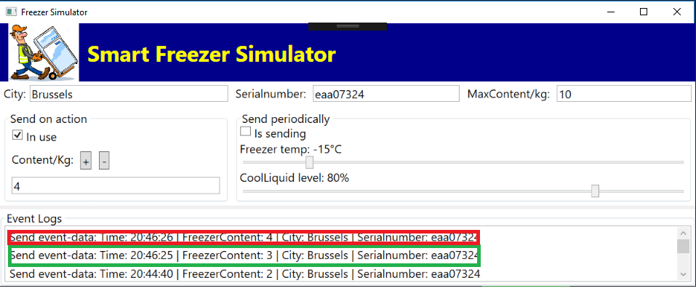

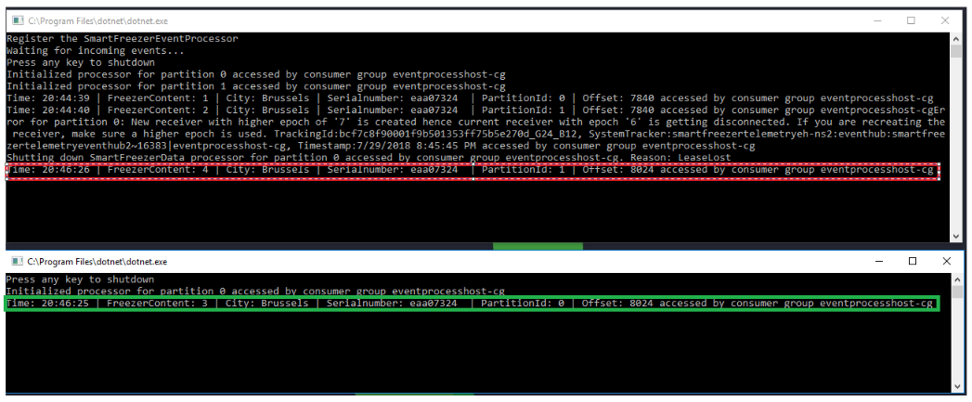

# Analyzing Real-time data with Stream Analytics and PowerBI

## Introduction

In this part, I will setup a **Stream Analystics** job in **Azure** that pulls the events from our **Event Hub** and pushes the to **Power BI.**

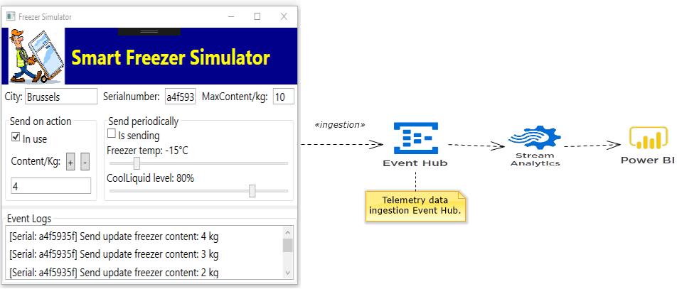

We will keep the scenario quit simple and report the periodical events from the **freezer temperature** and **cool liquid level** to the **Power BI** dashboard. That means that we have next requirements:

* Capture periodical events (among others …) from freezer temperature and cool liquid level sensor values and push them to the telemetry data ingestion event hub.
* Create a Stream Analytics job which will filter the periodical events from the event stream and send them to Power BI.
* Create a Power BI real-time dashboard with a simple graph which shows current temperature and cool liquid level on a periodical base (e.g. refresh each 10 seconds).

What we will do to achieve this:

* We start by setting up a Stream Analytics job in the Azure Portal.
* Next we define the Telemetry data ingestion Event Hub as an input for the Stream Analytics job and define Power BI as the output.
* Next we will write the query in the Stream Analytics job that is necessary to connect the input with the output .
* Next we will start the Stream Analytics job which will push the data from the Telemetry data ingestion Event Hub to Power BI.
* In Power BI we will create a real-time dashboard that displays the current temperature and cooling liquid level of a connected device.

## Setup a Stream Analytics Job

### Steps

* Setup a Stream Analytics Job.
* Define the Event Hub as an input.
* Define Power BI as an output.
* Write the query in Stream Analytics.

**Azure Portal > Add > Internet of Things > Stream Analytics Job**

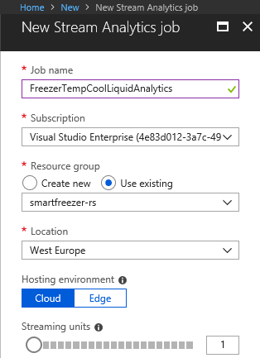

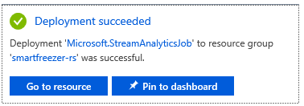

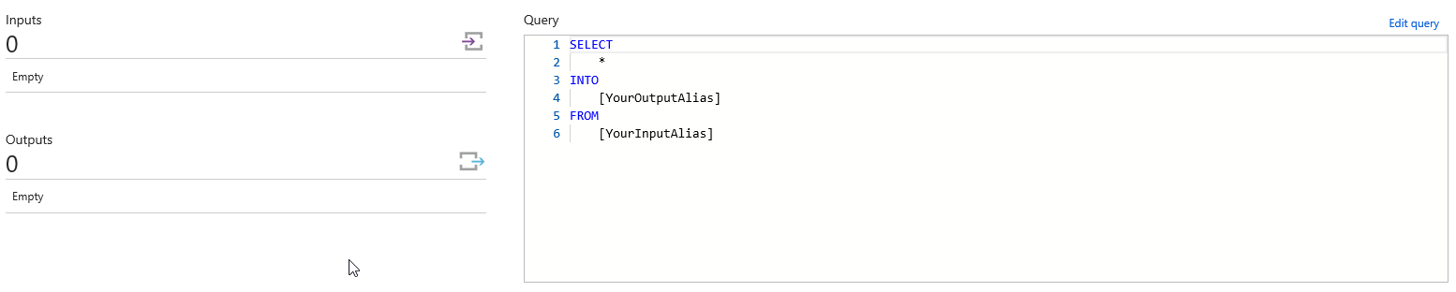

A Stream Analytics job has **inputs** , **outputs,** and a **query.**

### Define the Telemetry data ingestion Event Hub as Input

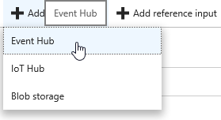

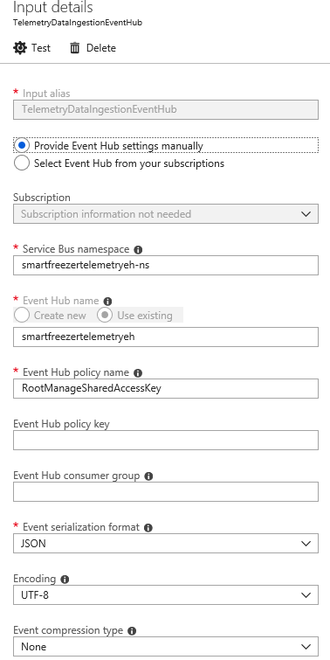

### Define Power BI as Output

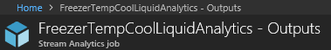

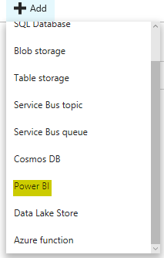

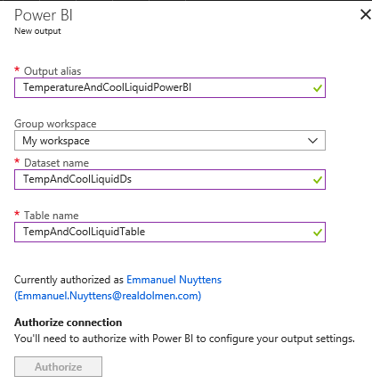

You need a valid PowerBI account to to this !

Next, we login to PowerBI & We Start our Device and check the **Is Sending** checkbox. This way data will be sent to the **Telemetry data ingestion Event Hub** and be routed to our **Stream Analytics job** which is running … After a while we see the created dataset in Power BI:

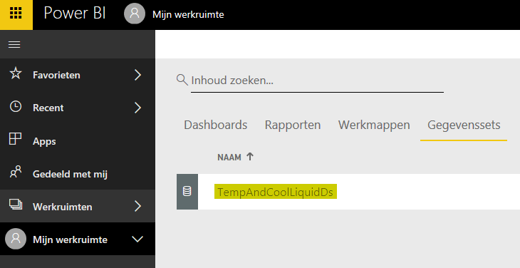

When we open the dataset, we get next:

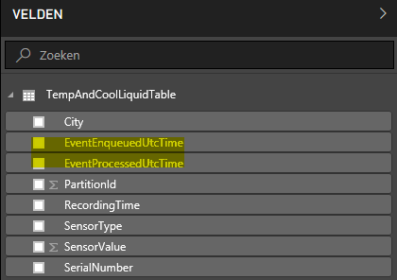

These are the fields or the FreezerEventData dataset. The dataset also contains 2 extra fields:

* EventEnqueuedUtcTime
  + This is the date time when the event was received by the Event Hub.
* EventProcessedUtcTime
  + This is the date time when the event was processed by Stream Analytics.

Now we should only send the **columns** to **Power BI** that we really need and these are next fields:

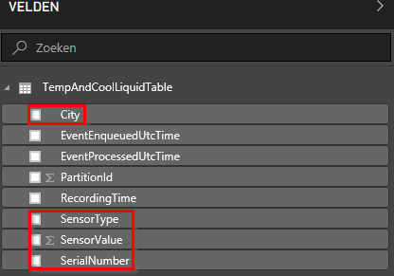

To achieve this, we have to adapt the query:

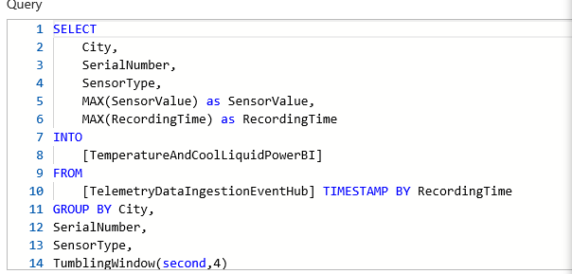

Next we create the Power BI dashboard:

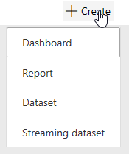

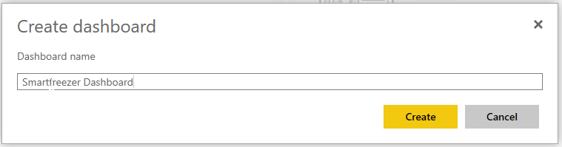

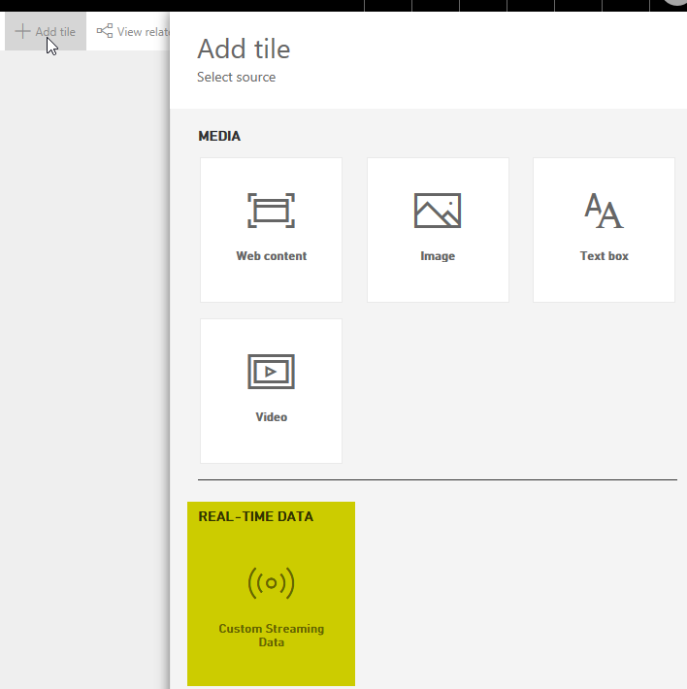

After adding a new dashboard, we add a tile. The input for the Power BI report will be REAL-TIME data from our Stream Analytics source.

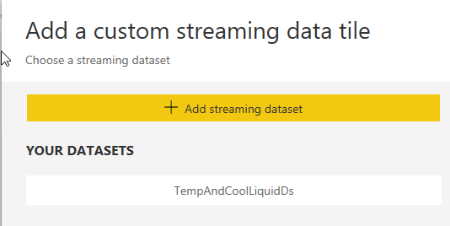

We select the DataSet from our Stream Analytics Source.

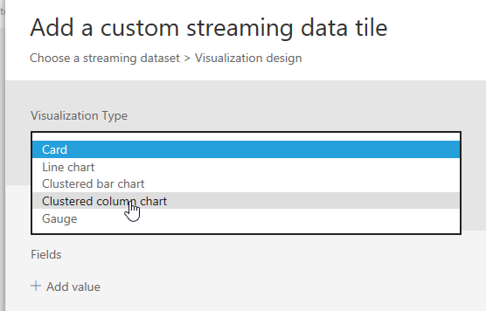

For this demo, we will create a “Clustered column chart”.

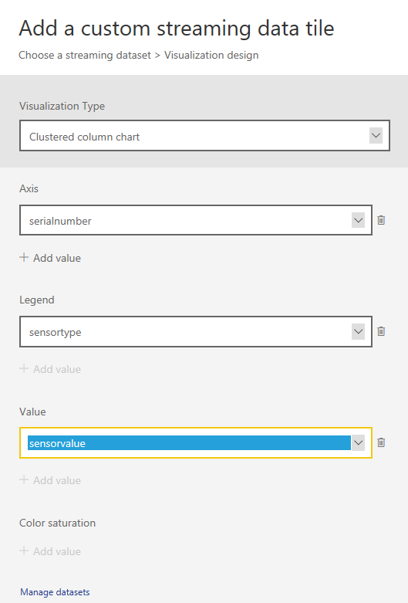

Axis value will be **SerialNumber,** Legend will be **Sensortype** and value for the graph will be **SensorValue.**

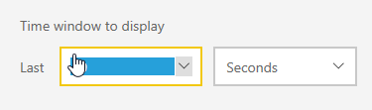

We next define a time window of 10 seconds. This means we will always display telemetry event data from last 10 seconds.

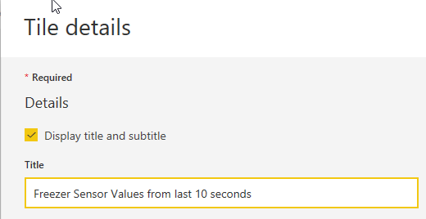

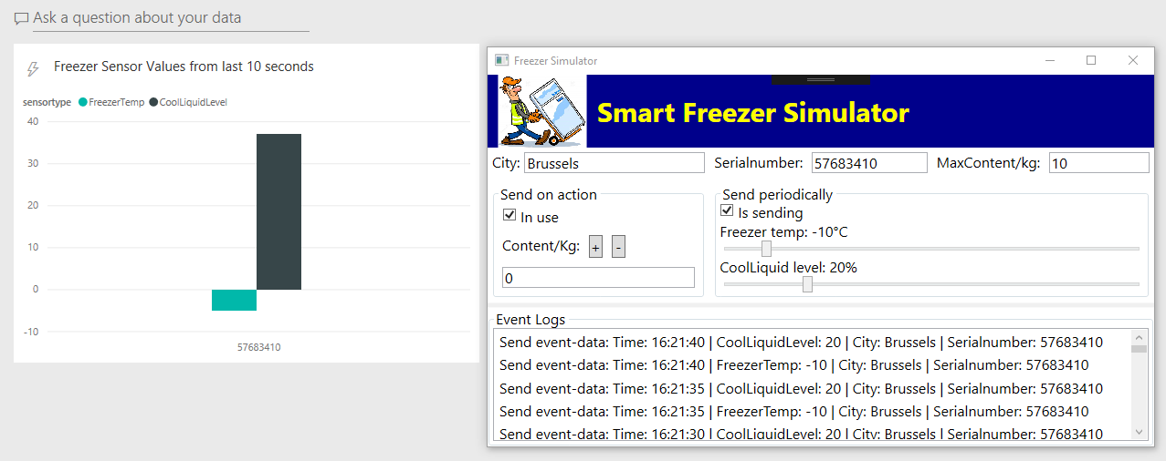

Finally we start our application and data appears in the Power BI dashboard.

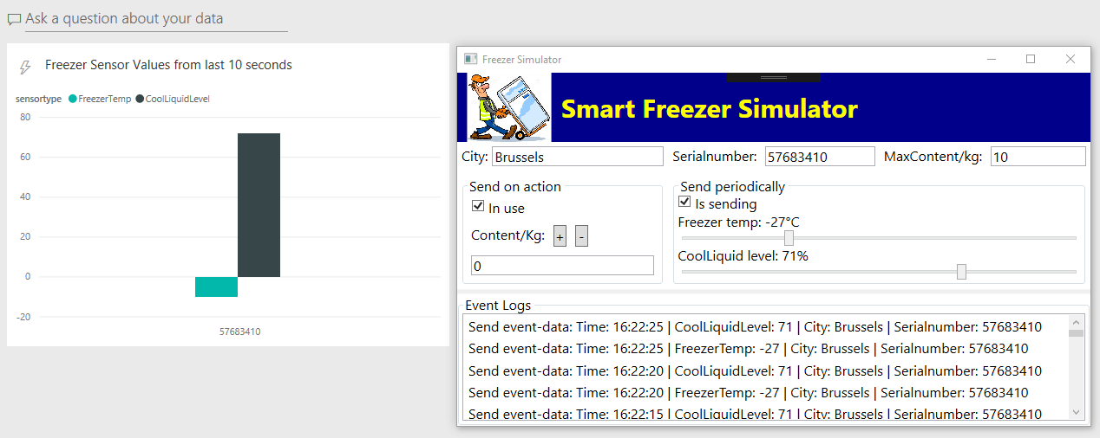

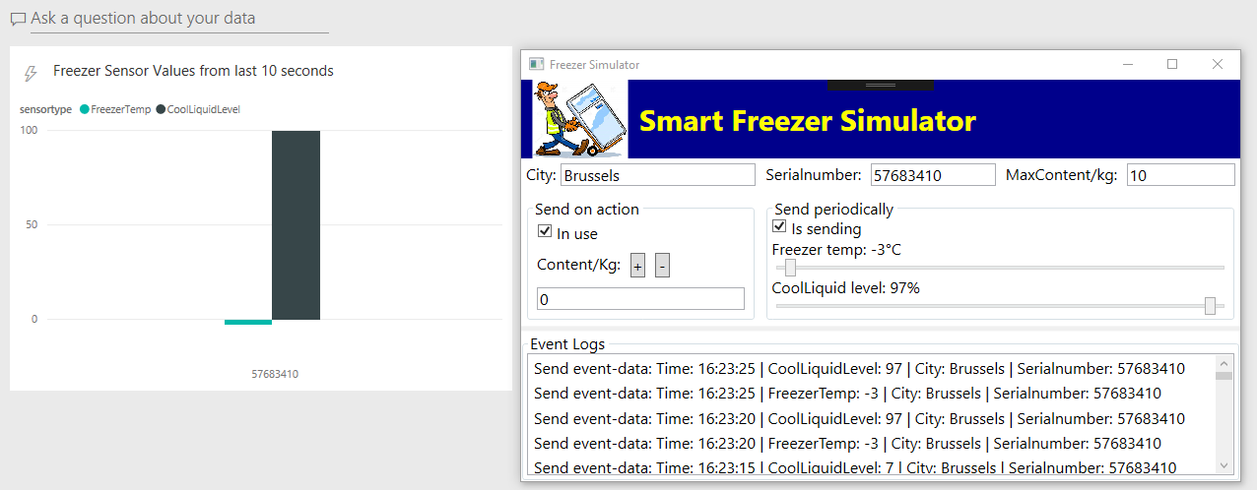

Every change on **temperature** and **cool liquid level** is shown in our BI graph.

Now let’s add another device instance:

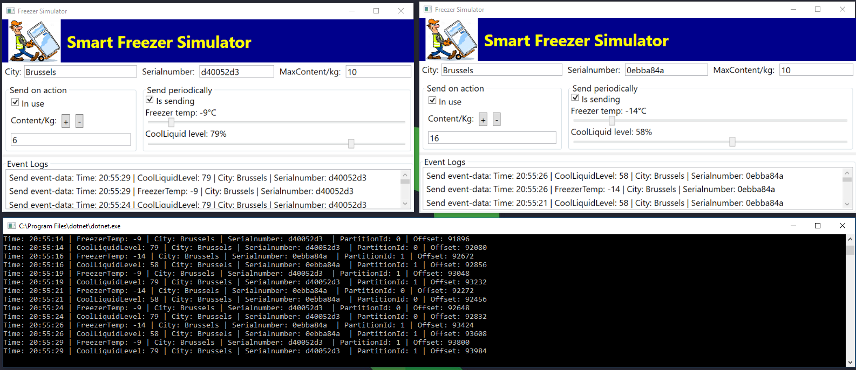

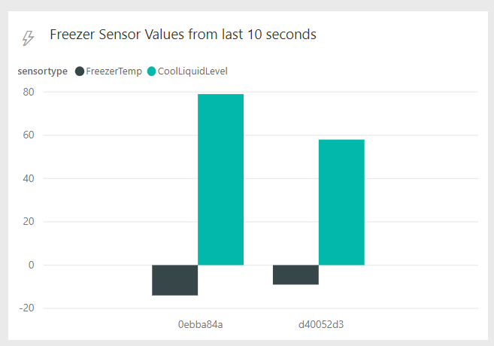

The BI graph adapts accordingly …

# Archiving Events with Event Hub Capture

## Introduction

In this chapter I will explain how we can store all the events of the **Telemetry data ingestion** Event Hub in an **Azure Blob Storage** by using the feature that is called **Event Hub Capture.**

By storing all events from the Event Hub in Azure Blob Storage, the events can be analyzed for future usage. So storing the incoming events in an Azure Blob Storage is a kind of archiving for later analyzing purposes.

These are the steps that we will execute:

1. Turn on Event Hub Capture in the **Telemerty data ingestion Event Hub.**
2. Check the stored data in the **Azure blob storage.**
3. Read archived events from the Azure blob storage with a .NET (Core) App.
4. Calculate costs for your Event Hub when **Event Hub Capture** feaure is On.

## Turn on Event Hub Capture

|  |  |
| --- | --- |
|  | We first have to create a new **storage account,** we select **blob storage** location in **West Europe** and use our existing **smartfreezer-rs** resource group. |

Next we go to the **smartfreezertelemetryeh-ns** event hub namespace and select the **smartfreezertelemetryeh** event hub **capture** feature and set in **On.**

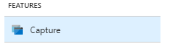

Select the container, when selecting the container you need to select the **storage account,** next create a new container in the storage account called **eventhubcapture.**

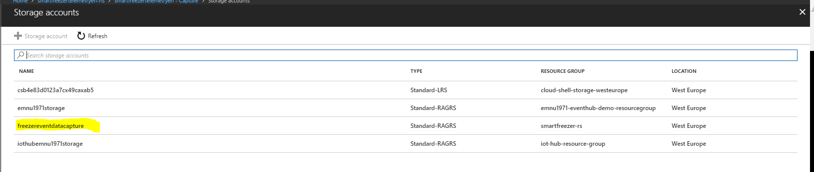

Select the storage account.

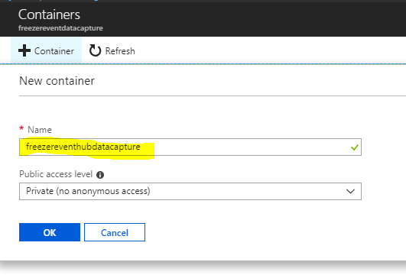

Create a new container in the storage account.

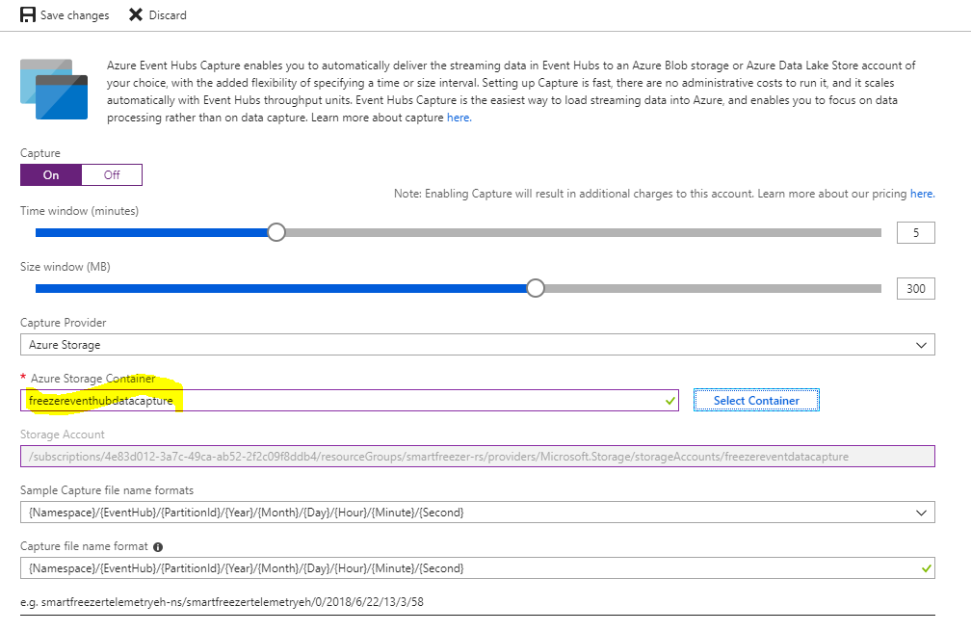

Select the container.

|  |  |
| --- | --- |
|  | **Info:**  *To Enable* ***event capture,*** *Event Hub namespace must be of type* ***standard tier****.* |

## Look at the Stored Data in Cloud Explorer

Next open the SmartFreezer app and create some data … Open **Cloud Explorer** (from the View window in Visual Studio)

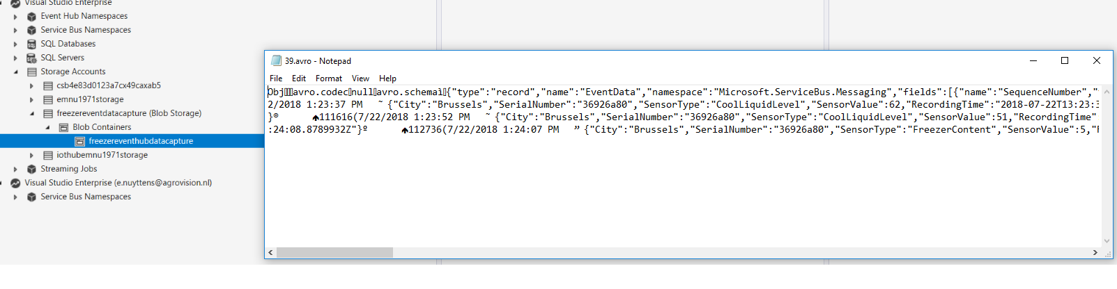

Data is stored in **avro** format (kind of JSON). As specified in the **Capture** property, we will have a file for each **5 minutes.**

## List the Captured Files in a .NET (Core) Console App

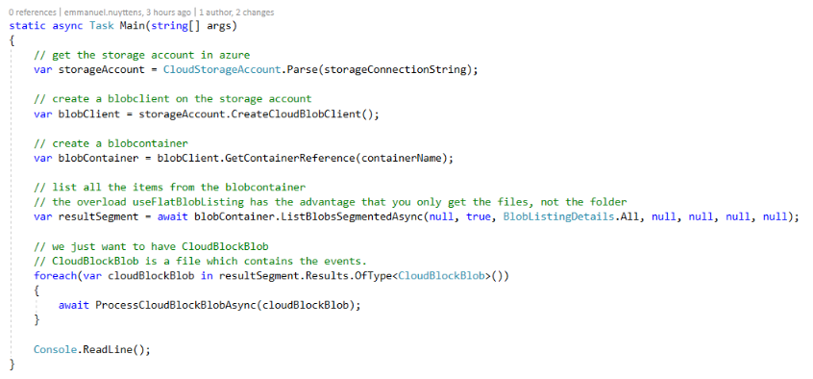

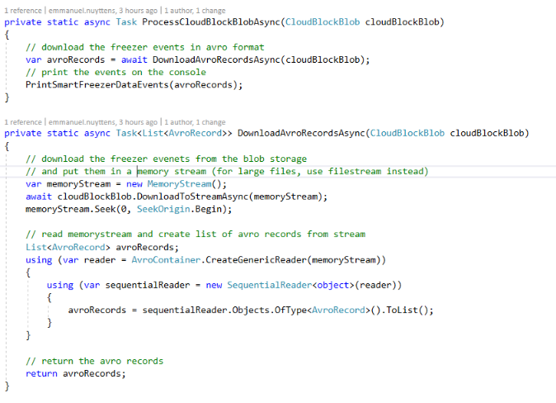

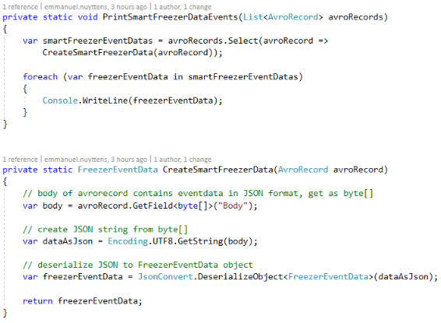

## Calculate the Costs



# Sending notifications using Azure Functions and Logic App

## Introduction

Another requirement of our SmartFreezer scenario is that the CEO should be notified when **the content of a SmartFreezer exceeds the maximum allowed content**. To achieve this we will use an **Azure Function** to filter the **“On Action”** events where content exceeds the max allowed content and send the result of this function to an **Alert Event Hub.** Next a **Logic App** will read the events from the **Alert Event Hub** and create a file in the **DropBox** instance of the CEO.

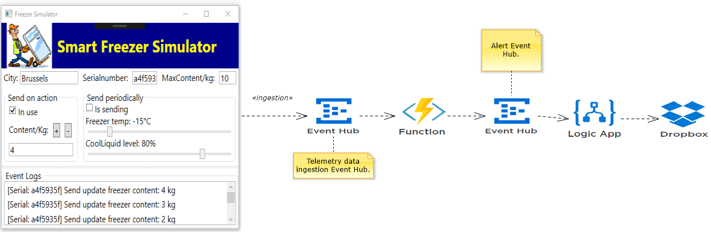

## Create Azure Function with Event Hub Trigger

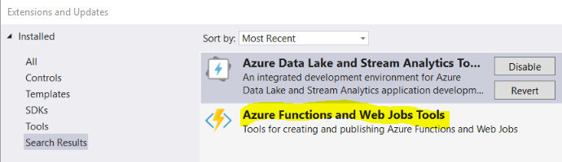

Azure functions can be created in Azure or locally in Visual Studio. We will create an Azure function locally in Visual Studio. For this in **Extensions and Updates**, the extension **Azure Functions and Web Jobs Tools** should be installed.

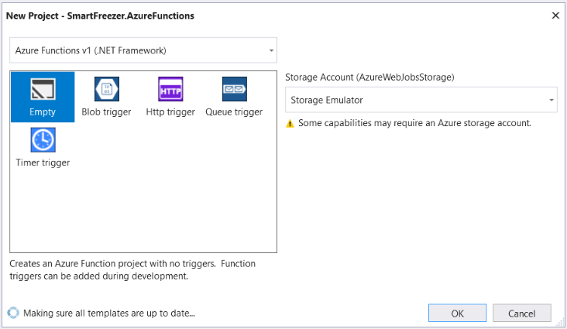

Select the **Empty** template. This will create an Azure Function project with no-triggers.

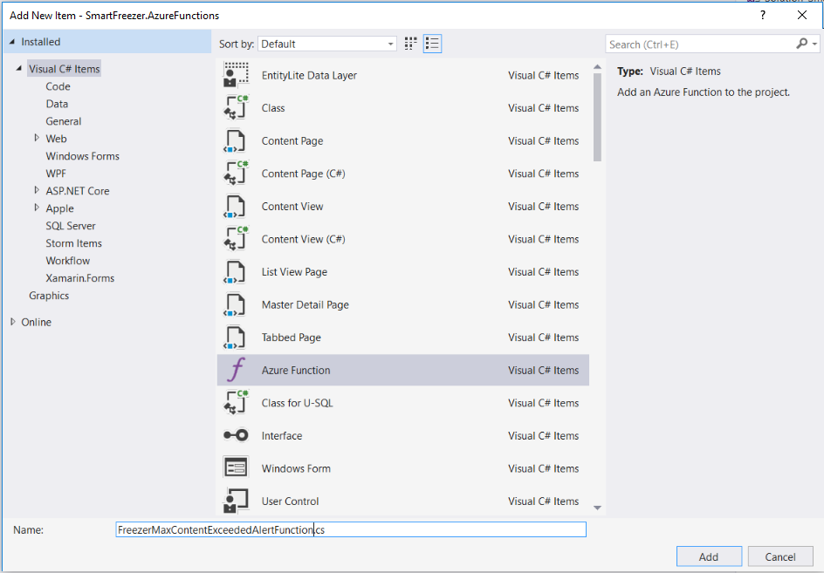

Add a new Azure function to the project, triggered by an **Event Hub Trigger** (Telemerty Data Ingestion Event Hub).

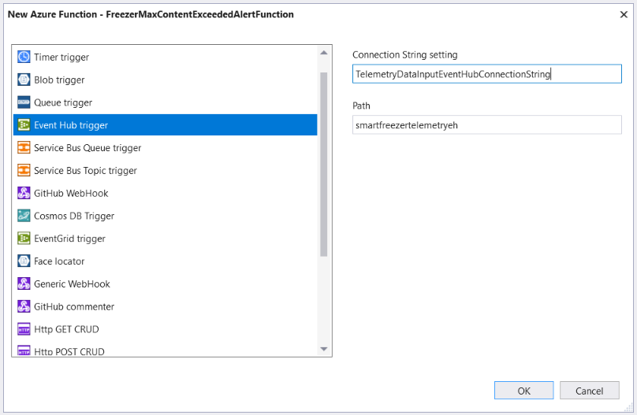

**Path** is the name of the Event Hub. **Connection** is the key to the connection string in the configuration not the connection string itself, so you can call it whatever you want …

The initial **function app** looks as next:

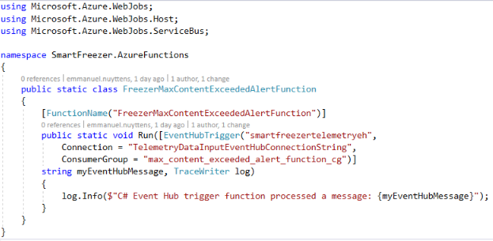

The function has a reference to the **input Event Hub**, we also created a specific consumergroup for the function app and all events from the event hub will result in a **myEventHubMessage** object that we initially output to the log console of the function app:

Next, add the ConnectionString of the (Event Date Input) Event Hub to the JSON configuration file : **local.settings.json**.

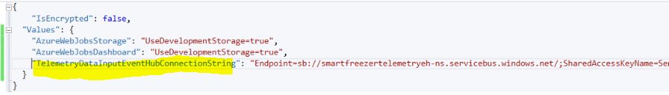

## Run the Azure Function Locally

To run the Azure Function you must first run the **storage emulator** locally. In the **local.settings.json** file we have the property “**UseDevelopmentStorage=true”** for the key **AzureWebJobsStorage.**

When the **Azure SDK** is installed with Visual Studio, then the **Storage Emulator** will be installed on the local computer.

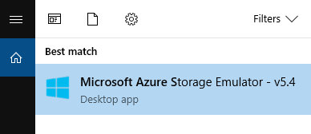

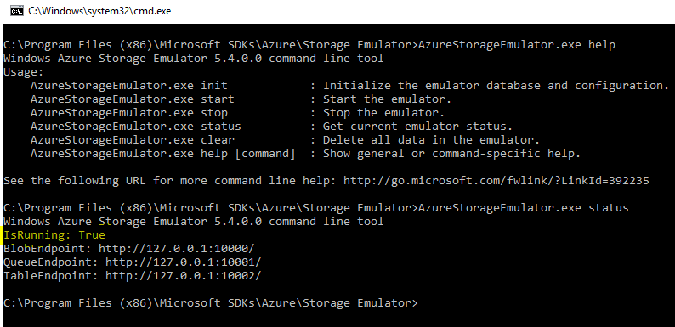

After the **Microsoft Azure Storage Emulator** is started, we first start the **azure function app** in **Visual Studio** and next we open the **SmartFreezer Simulator UI App** and generate some data, the event data is logged in the function app.

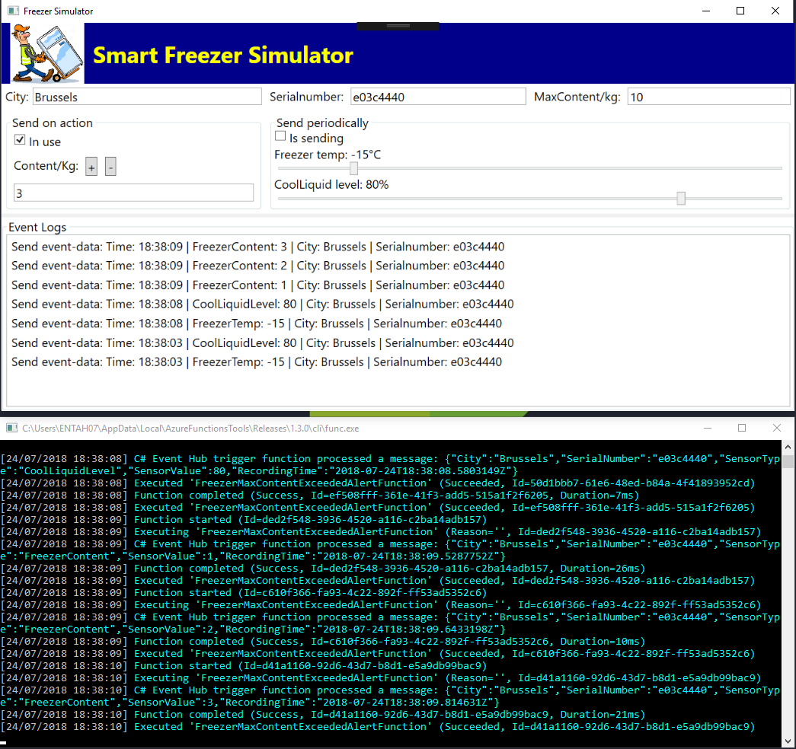

## Process Events in Batches and Deserialize to FreezerEventData

The function is started, executed and comleted for every single event in de Event Hub. Performance can be increased by receiving and processing events in **batch.** To do this we need to change the type of the parameter **myEventHubMessage** from **string** to **string array.**

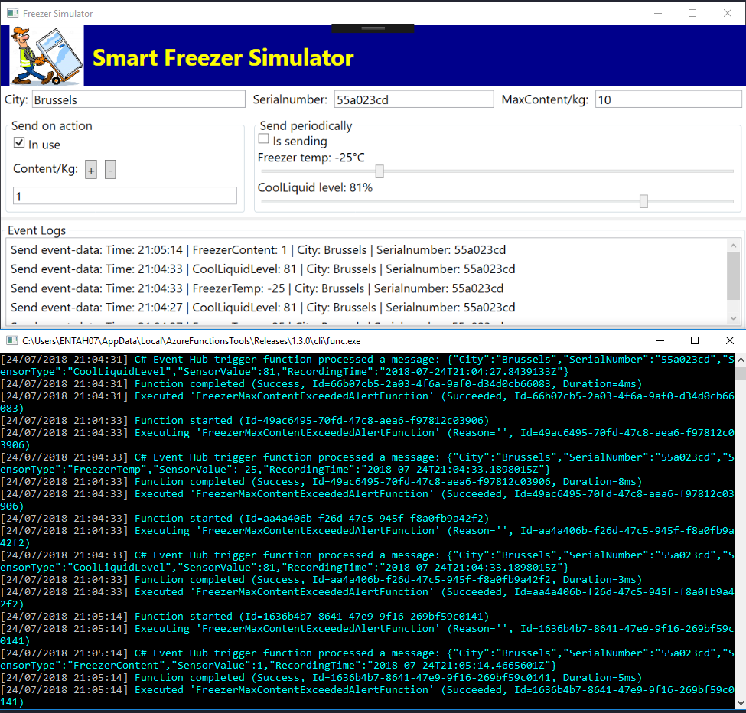

Now we will have a single **Function Started** and messages will be processed in batch:

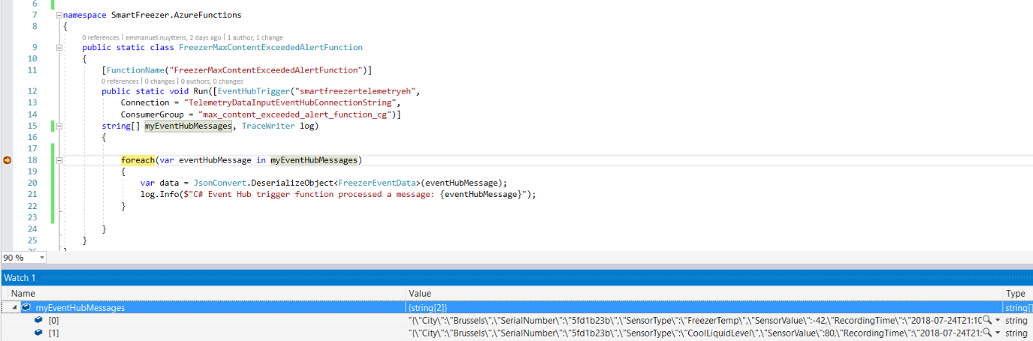

## Deploy the Function App to Azure

To deploy the function app to azure, in solution explorer right click on the function app project and select “Publish”:

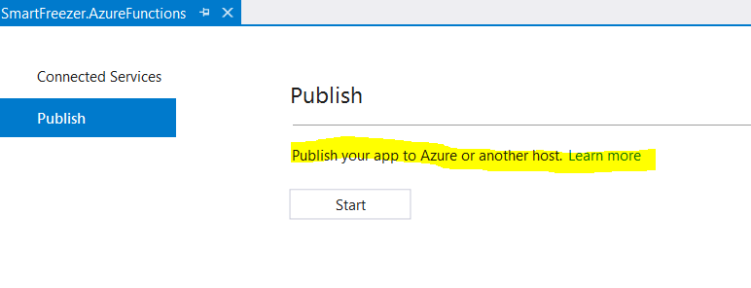

We can publish to Azure or another host, we will publish to Azure.

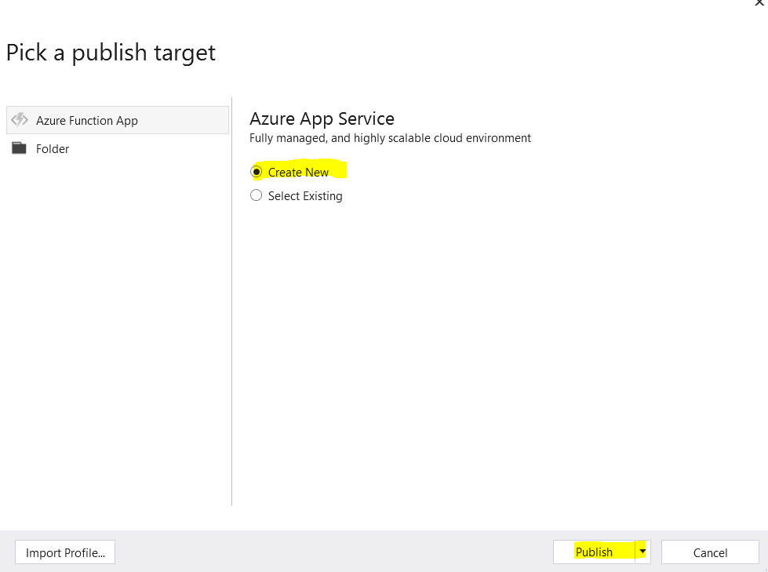

Select “Create New” and “Publish”.

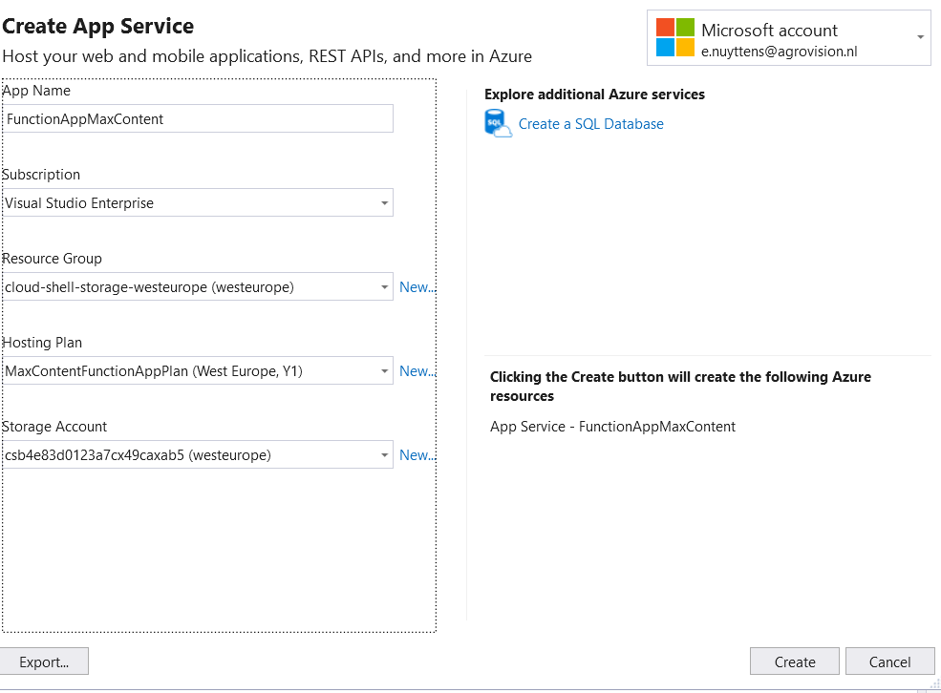

Click “Create” to deploy the function app (may take several minutes to deploy to Azure).

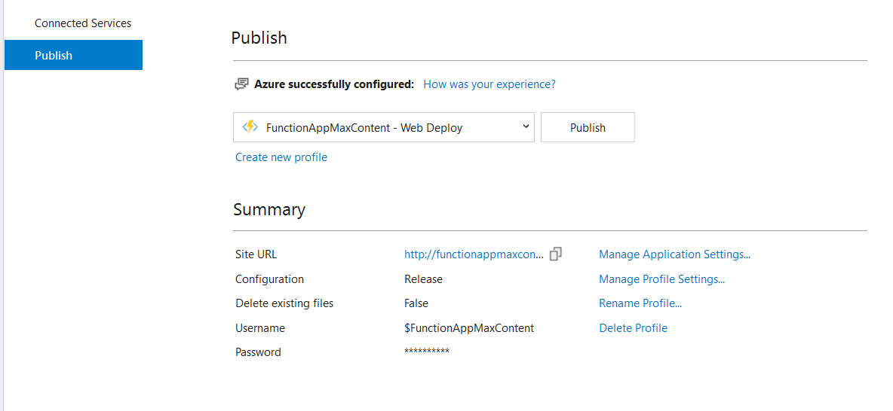

The function app was deployed and a profile was created.

Next you will still have tot add the remote connectionstring for the connected source eventhub, open the **local.settings.json** file first:

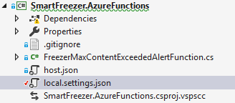

Next take the value of the endpoint connection string:



Next select publish of the azure function:

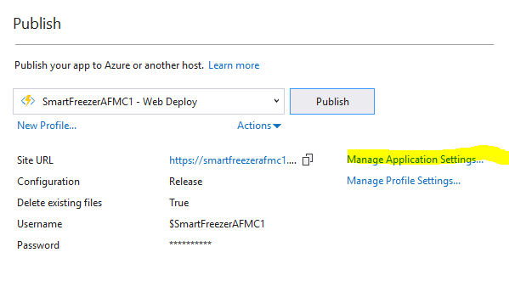

Select “Manage Application Settings …”

Complete the remote value for the connection string and save:

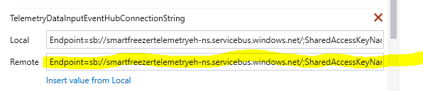

Finally go to the portal to check if the connection string was update in the function:

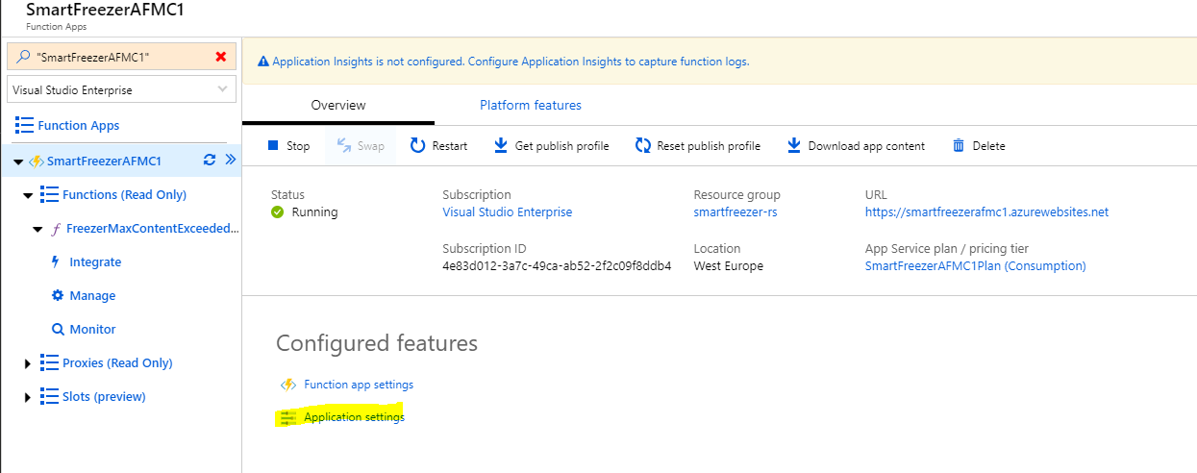

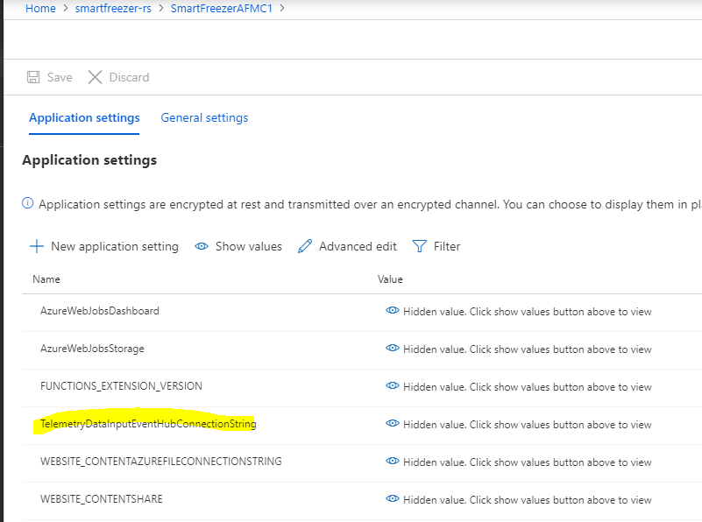

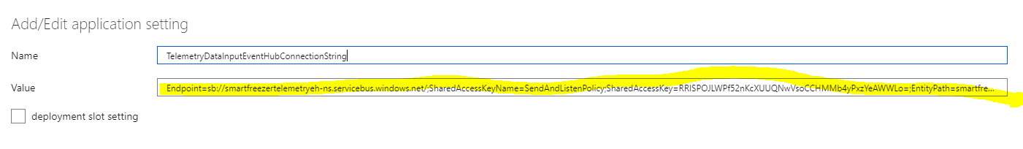

Finally, be sure that the funcation app is running in azure, add some events to the wpf simulator and check the logs:

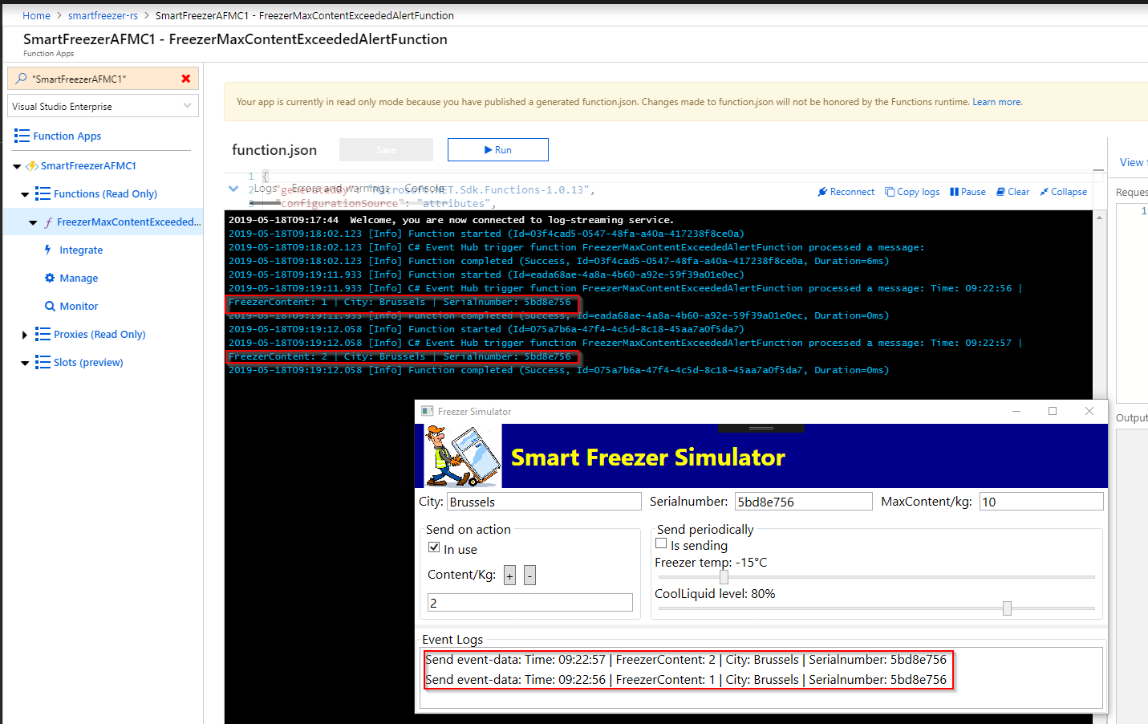

## Setup an Alert Event Hub

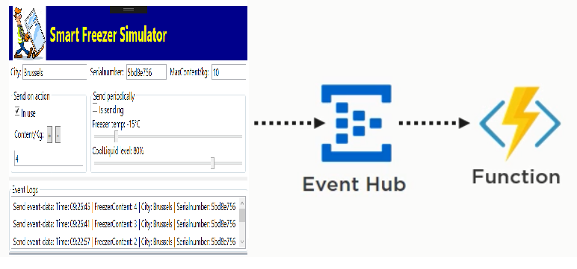

We have created and deployed an azure function which receives events from our **TelemetryDataInputEventHub.**

Next we will have to adapt our azure function so that when the **maxcontent** of the freezer is reached, then it should write an event message to another event hub, let’s call it **MaxContentReachedAlertEventHub.**

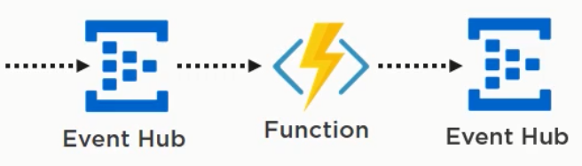

So in azure portal, we first have to create this Event Hub: (+ create a new shared access policy **SendAndListenPolicy** to have a connection string to the event hub):

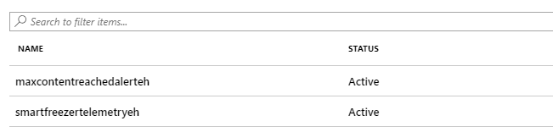

Next take the connectionstring from the created policy and add it to the local.settings.json file in the visual studio created function app:

{

  "IsEncrypted": false,

  "Values": {

    "AzureWebJobsStorage": "UseDevelopmentStorage=true",

    "AzureWebJobsDashboard": "UseDevelopmentStorage=true",

    "TelemetryDataInputEventHubConnectionString": "Endpoint=sb://smartfreezertelemetryeh-ns.servicebus.windows.net/;SharedAccessKeyName=SendAndListenPolicy;SharedAccessKey=RRISPOJLWPf52nKcXUUQNwVsoCCHMMb4yPxzYeAWWLo=;EntityPath=smartfreezertelemetryeh",

    "TelemetryDataOutputEventHubConnectionString": "Endpoint=sb://smartfreezertelemetryeh-ns.servicebus.windows.net/;SharedAccessKeyName=SendAndListenPolicy;SharedAccessKey=teG+iaIt1BFmjG8XkMw9xrVxOBtgAYsgihJx3aQ/LkU=;EntityPath=maxcontentreachedalerteh"

  }

}

We have 2 connection strings now, the first as input to the AZF, the latter as output.

## Write From the Function to The Alert Event Hub

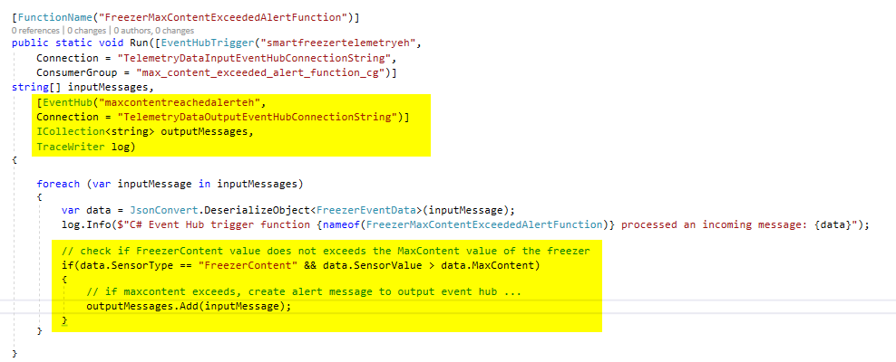

So the content of the function changed as I’ve added the **output eventhub** and the function tests if the **message is of type FreezerContent,** and if so, if the value exceeds the max value, then the message will be written to the **output event hub.**

Next save and publish to azure … but first don’t forget to add the remote output eventhub connectionstring in the app settings:

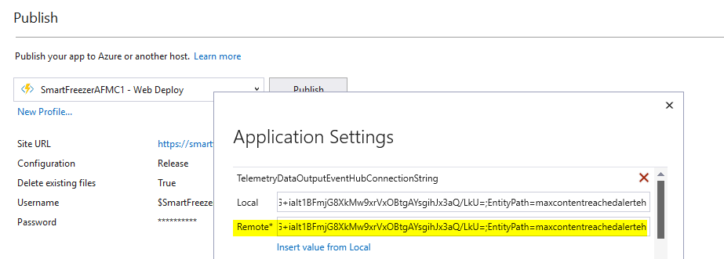

After publishing, we can test the Azure function in Azure portal, first start the function:

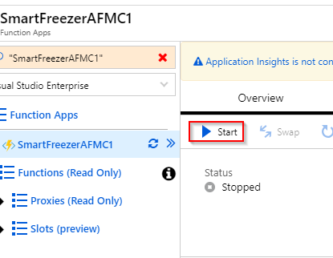

Next point to the function itself and click “Run”.

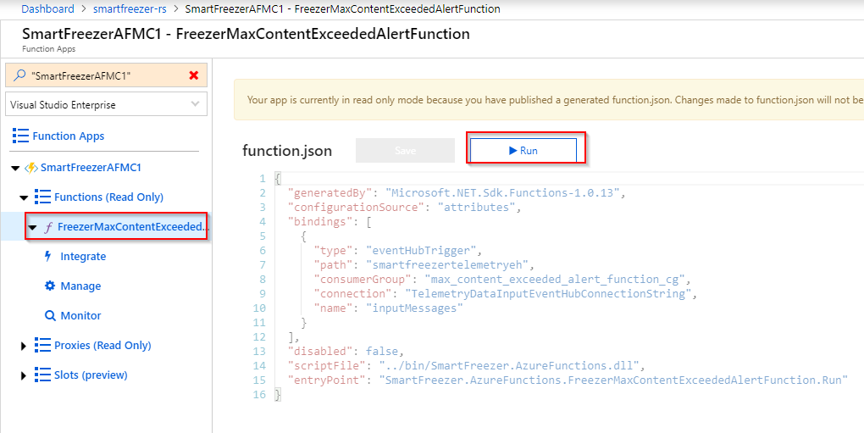

Finally start the simulator and add some content:

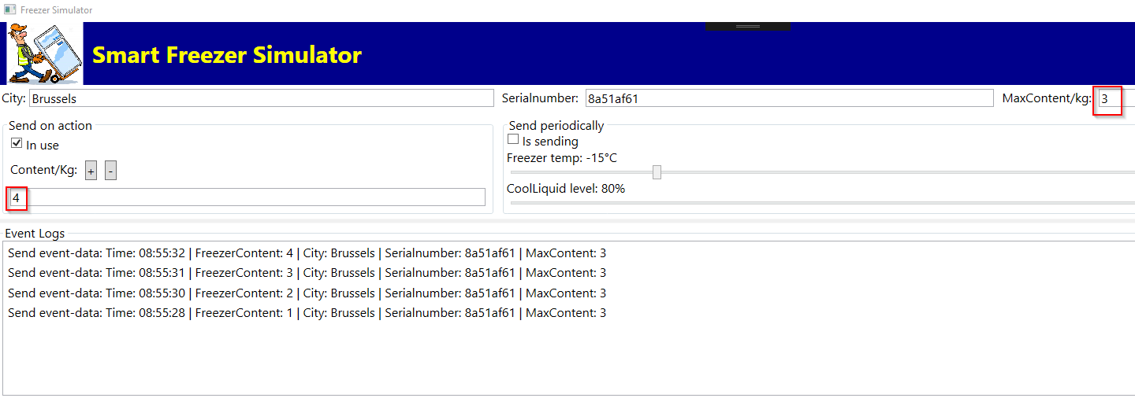

Messages are received by function and output message is created in case of max-content exceeded:

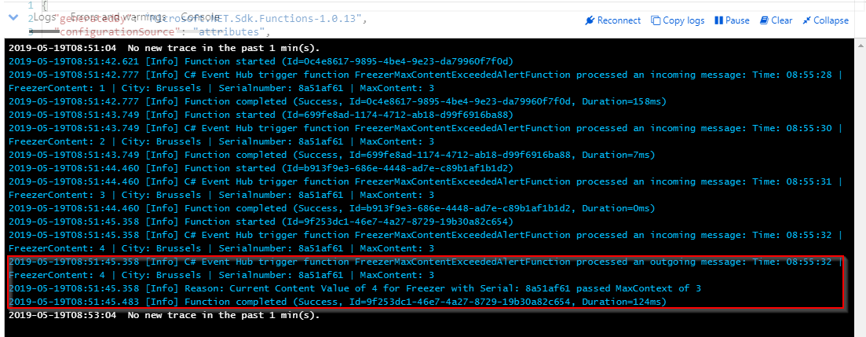

## The Function and the Output Alert Event Hub in Action

Previous we have seen how to setup an output event hub where the Azure Function writes messages to if max content exceeded.

Now to see the events stored in the second output event hub we will use the .NET Core app that we build previousely to see all messages of the event hub.

We can simply achieve that by changing the connectionstring in the Consuming project (e.g. the one which reads all partitions of the eventhub) and set the connectionstring to the one of the output alert event hub.

## Create a Logic App with an Event Hub Trigger

We will create a **logic app** in the Azure Portal. The logic app is like a workflow. We will start this workflow when events are available in the **Max Content Exceeded Alerts Event Hub.** Then the logic app will parse the JSON and create files in **drop-box.**

But before creating a logic app, let’s add a specific **consumer group** in the **MaxContentReachedAlertEvenHub.** Let’s call the consumer group **smartfreezer**_**max_content_reached_logic_app.**

Next let’s create the logic app:

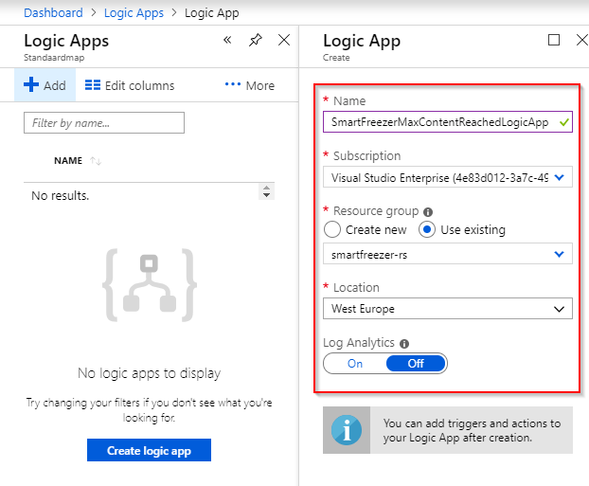

Next click “Logic-App-Designer”. Select “Blank Logic App”:

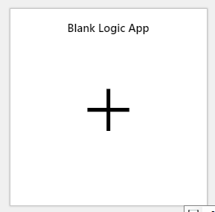

Next search for “Event Hubs”

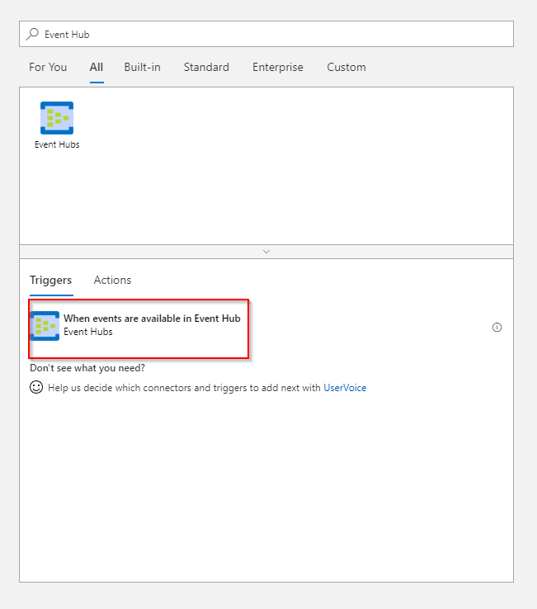

Next select “When events are available …”

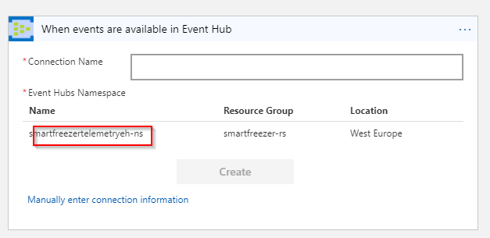

Click on the event hub namespace.

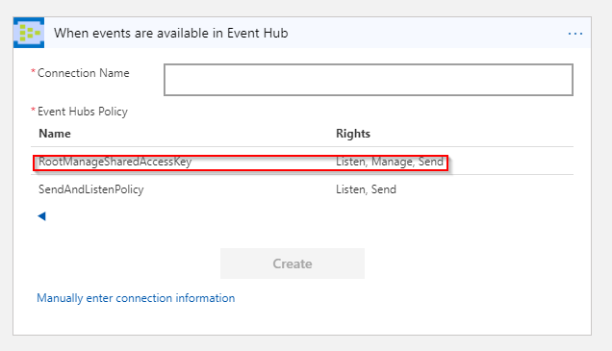

Click on the **RootManagerSharedAccessKey**.

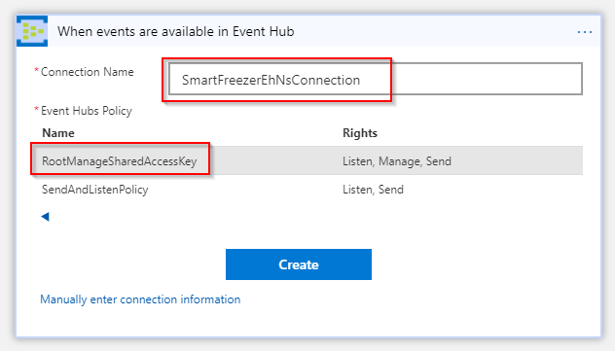

Enter the connection name… + Create

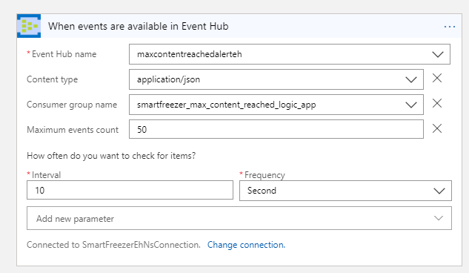

Select the output alert event hub and set the consumer group, change the polling interval to 10 seconds. + Save … Next select overview.

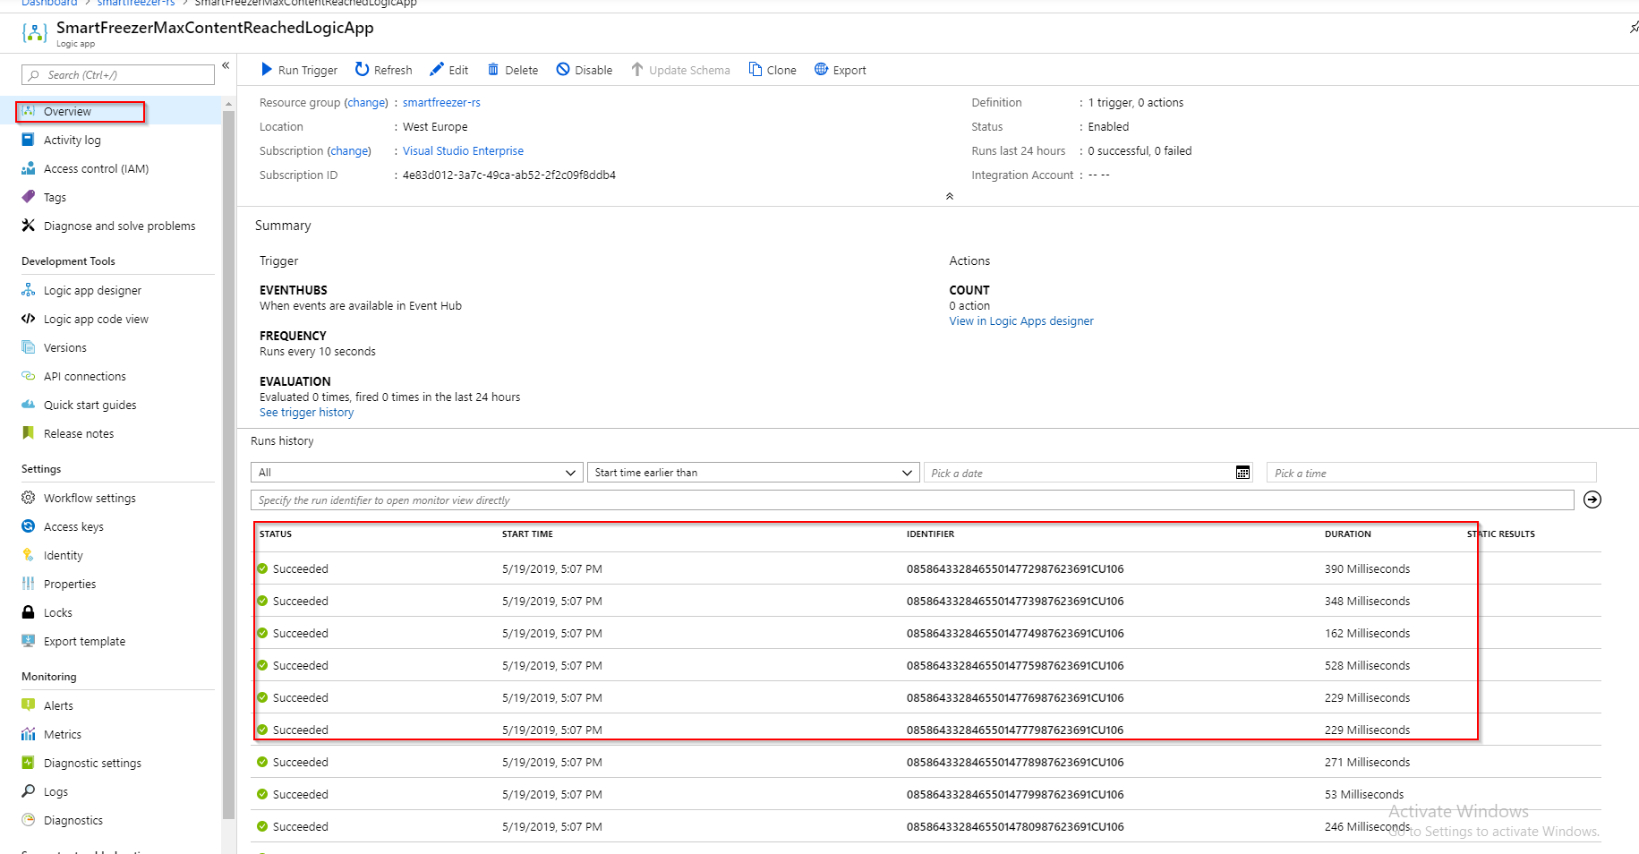

Now you see the triggers that already had been executed from event data that exceeded the max-content (add of event message to the output event hub).

## Parse the JSON in the Logic App

We saw already that the Alert Logic App was already executed some times, each for one message that exceeded the max-content and was written to the maxcontent exceeded output event hub. Let’s go back to the **Logic App Designer** first … and let parse the JSON for the events:

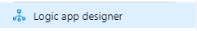

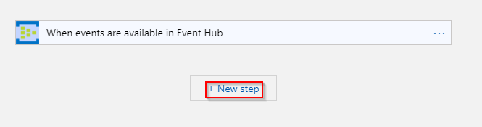

Select “New step …”

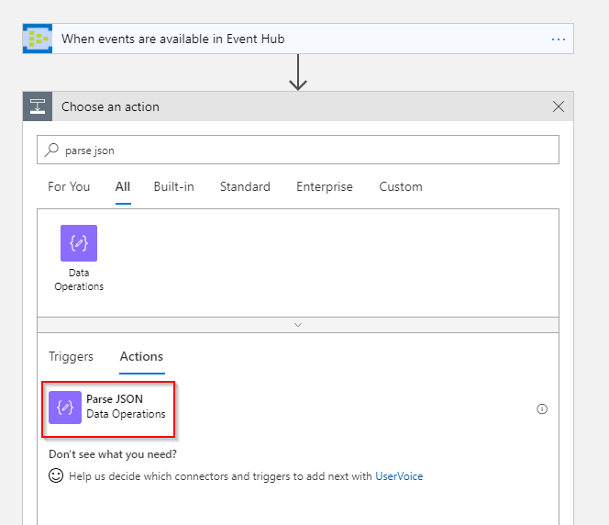

Now we need to define the content we want to parse. (to see the properties, the action should already been executed before !). Now select “Content” which contains the JSON string.

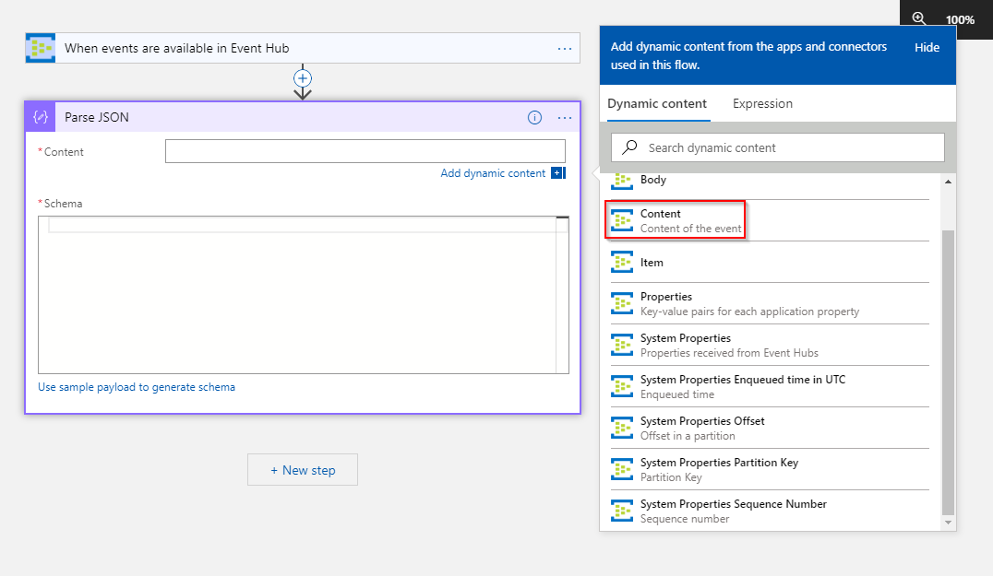

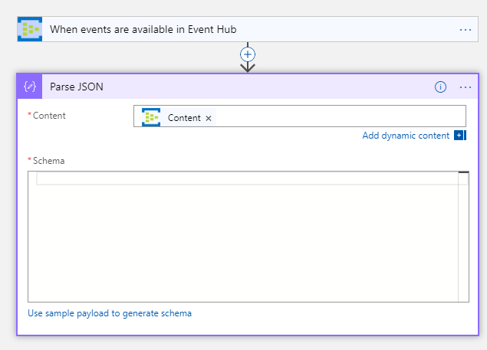

Next you need to define a schema. Select “Use sample payload …”. Now you have to manually provide one …

The schema that we have to provide is a JSON formatted schema of the domain model: FreezerEventData from the Domain Model project:

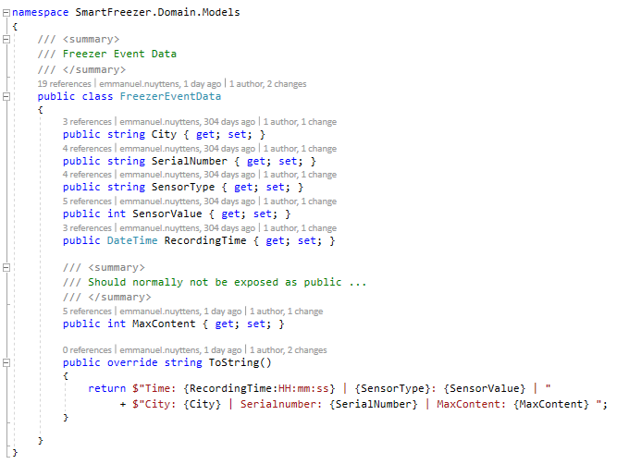

So, we have next as a sample:

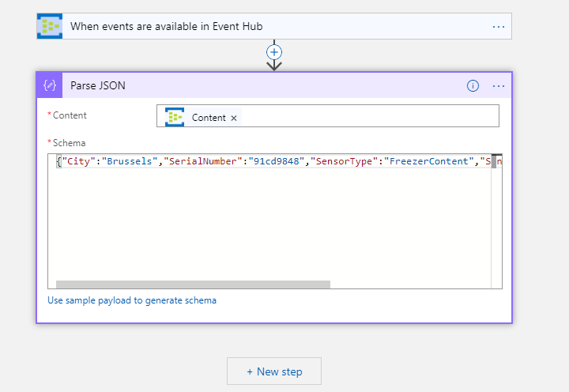

Save + go to overview, next select 1 of the already succeeded runs and select “re-submit”.

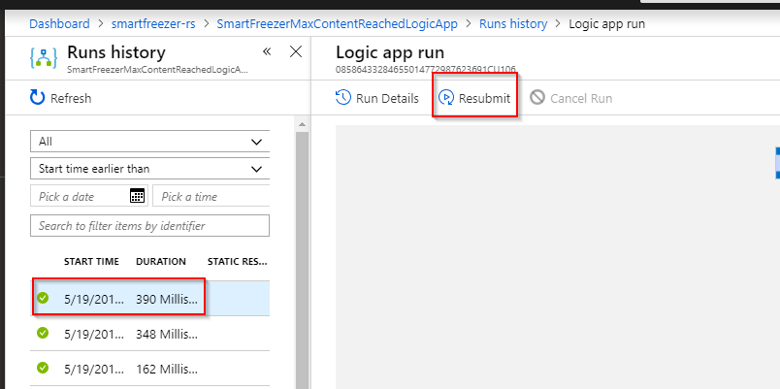

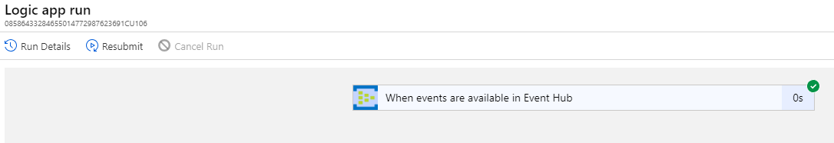

It succeeded ! Next scroll to the left to the blade of the logic app:

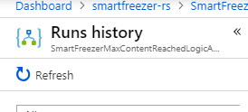

Select refresh !

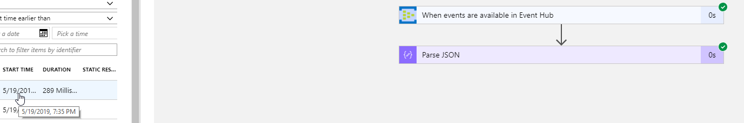

All went well !

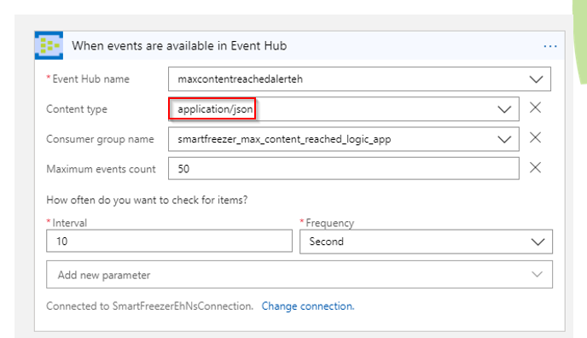

All went well because we selected “application/json” as the Content type that we should get from the hub !

## Write the Event Data to a DropBox Folder

We can use the events from the parsed JSON from the logic app to send an email or create a file in drop-box.

So, to do that, we have to add a step in our logic app process:

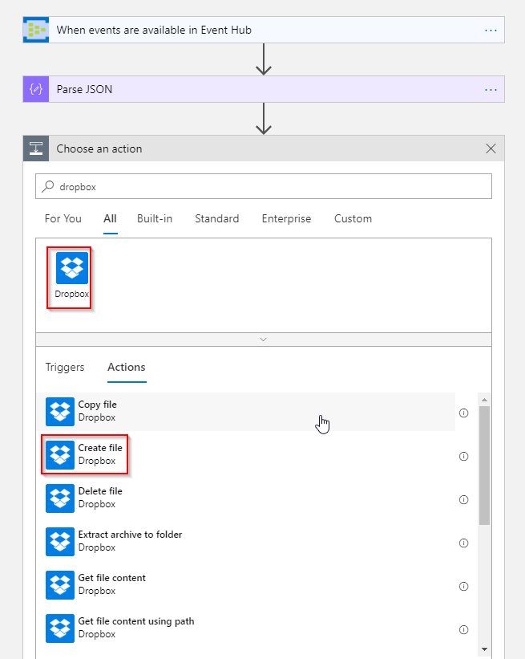

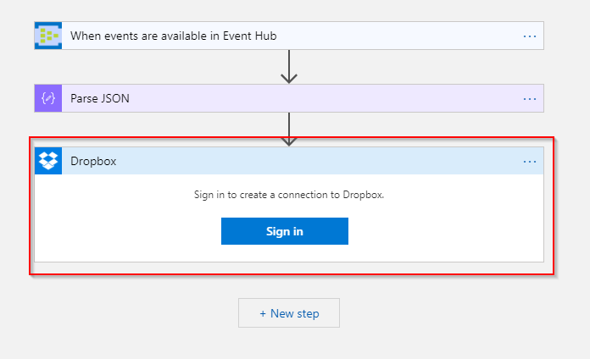

First you have to sign in to create a connection to DropBox.

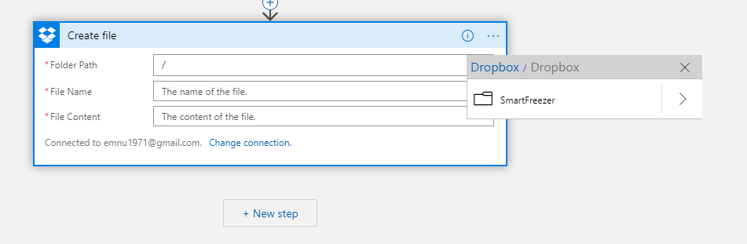

Next set folder.

# Appendix A: Resolve Missing Nuget Packages in UI

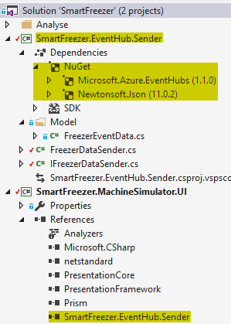

When we run the application after referecing the *Sender project in the *UI project we can get next error:

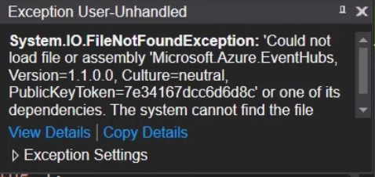

Problem is that the **Microsoft.Azure.EventHubs** is not copied to the output directory of the **\*UI** project. This is a known issue with the .NET Standard, and the full .NET Framework and there exists a work-around ! Just execute next steps:

**Right-Click on the *UI project and select “Unload-Project”:**



**Next Right-Click on the project again, and select Edit, so that we can edit the *CS project file:**

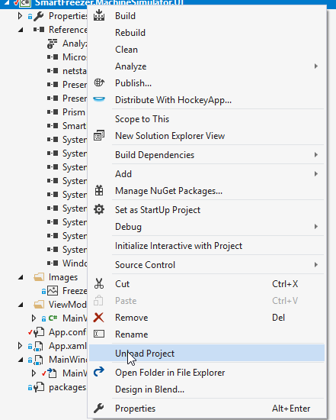

**Next edit the *CS project file:**

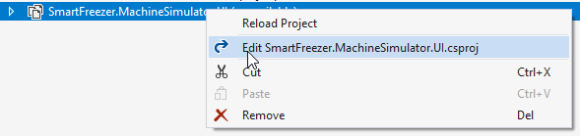

**Next, in the first “Property Group” , add an additional element that is called “RestorePojectStyle”:**

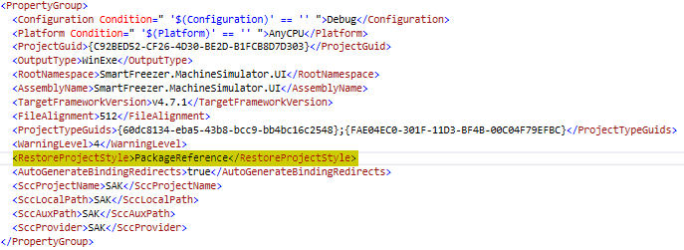

**Finally save the *CS project file, right-click on the project and reload the project. It should work now …**

# Appendix B: Visual Studio Project Structure

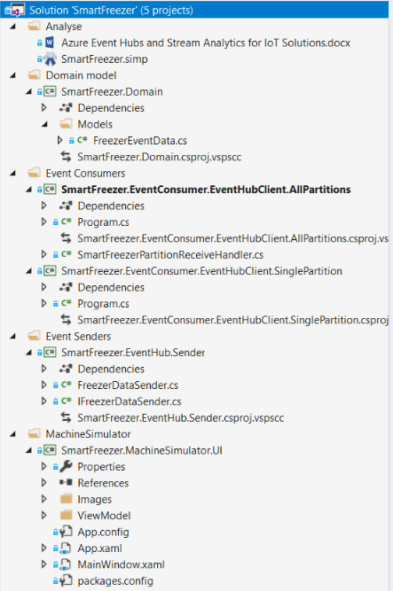

1. For our demo purpose, we won’t be using real IoT devices and freezer but simulate the freezer capabilities by means of a software application build in WPF !